**AMERICAN INTERNATIONAL UNIVERSITY–BANGLADESH (AIUB)**

**Faculty of Engineering (CSE)**

**INTRODUCTION TO DATABASE (CSC2108)**

**Fall 2022-2023**

**Section: O**

**ICE CREAM SHOP MANAGEMENT SYSTEM**

**Supervised By:**

***Argho Das***

|  |  |
| --- | --- |
| **Group Members** | **ID** |
| 1. **DIP ACHORJEE SHOKAL** | **22-46788-1** |
| 1. **MD. FAYSAL KABIR** | **22-46783-1** |
| 1. **MD. GALIB SHAHRIAR SHOPNIL** | **22-46793-1** |

CASE STUDY:

In Ice-cream shop management system where store many information which is related with this shop like trend_license_number which is unique number, shop_name ,hotline_number and location. Many customers can visit to the shop at a time. They take sit and brows the menu card and order ice-cream. For every customer have a unique member_id which will help identify a customer easier way .Also store customer_name ,contact_number .The menu_card have a serial_number ,flavor_name, price. Menu cards take information from stock. After order ice-cream customer need to pay bill. Bill have date_of_payment ,bill_number,total_amount. At the same time shop may have many owners.And A owner can have many shop at a time but they have atlest one shop. So, here we also store owners information like owner_name ,contact_number, owner_id. owner_id is different for every owner. Many employees work for an ice-cream shop, and they divided by the job_level. Every employee have their unique employee_id and also store employee_name ,employee_salary ,joning_year, working _period and job_id .Employee give many services to customers and also they get order from the owners. Job_level_id is unique number for one level. Job level also have jobe_level_name and employee_id . Employee always looks after the stock. Stock contain flavor_name which is different for every flavor ,quantity ,buying_price ,selling_price ,production_date ,expired_date .Shop have at least one shock room. On the stock room store ice cream.

E-R DIAGRAM:

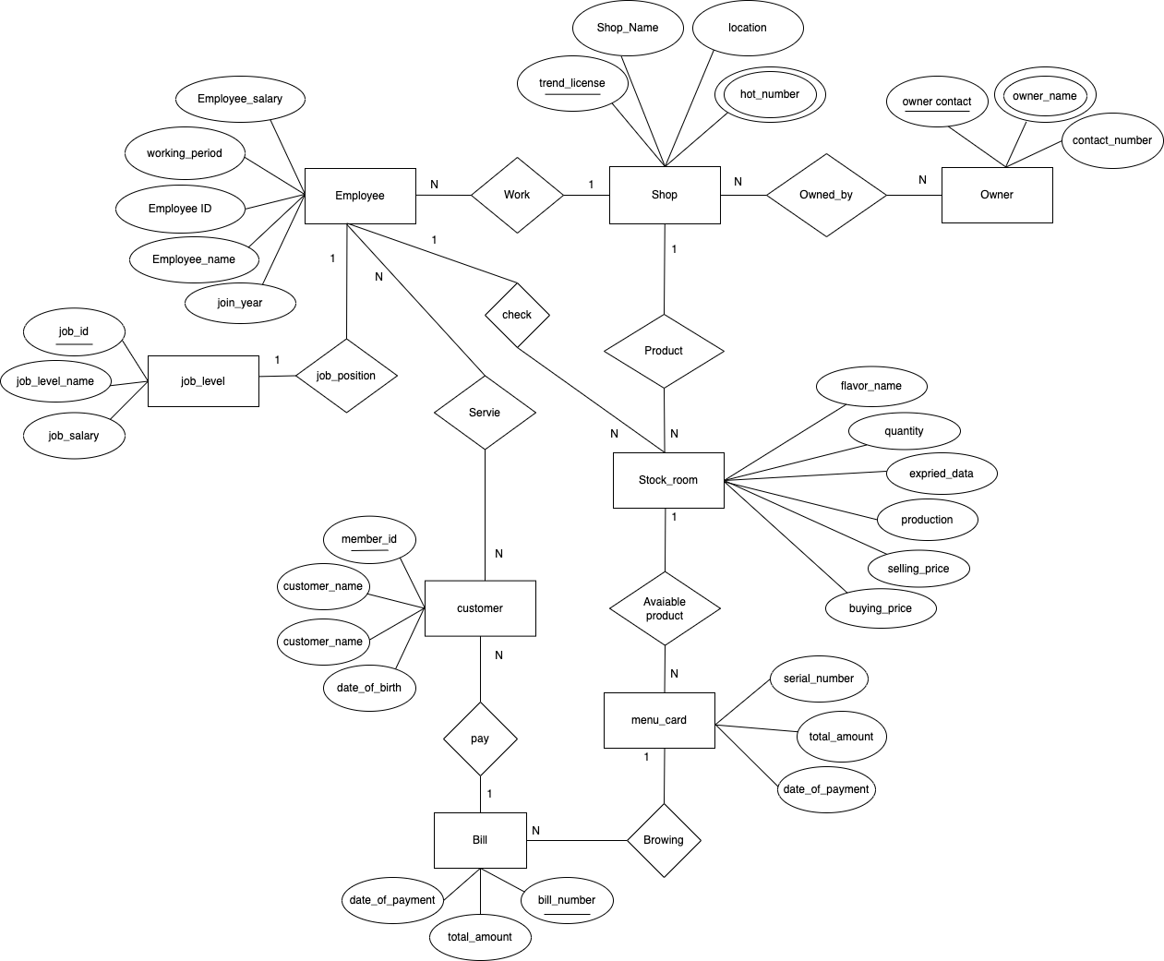

NORMALIZATION :

1. **Work**(trend_license,shop_name,hot_number,location,employee_id,employee_name,employee_salary,working_period,join_year)

1NF : hot_number is multivalued attribute .

2NF: trend_license,shop_name,hot_number,location.

employee_id,employee_name,employee_salary,working_period,join_year, trend_license.

3NF: trend_license,shop_name,hot_number,location.

employee_id,employee_name,employee_salary,working_period,join_year,trend_license.

TABLE :

1. trend_license,shop_name,hot_number,location, employee_id.
2. employee_id,employee_name,employee_salary,working_period,join_year.
3. **Owned**(trend_license,shop_name,hot_number,location,owner_id,owner_name,contact_number)

1NF : hot_number , owner_name is multivalued attribute.

2NF : trend_license ,shop_name ,hot_number,location.

owner_id,owner_name,contact_number, trend_license.

3NF : trend_license ,shop_name ,hot_number,location.

owner_id,owner_name,contact_number, trend_license.

TABLE:

1. trend_license ,shop_name ,hot_number,location.
2. owner_id,owner_name,contact_number, trend_license.
3. **Have**(trend_license,shop_name,hot_number,location,flavor_name,quantity,buying_price,selling_price,expire_date,production_date)

1NF : No multivalued attribute.

2NF : trend_license,shop_name,hot_number,location.

flavor_name,quantity,buying_price,selling_price,expire_date,production_date, trend_license**.**

3NF : trend_license,shop_name,hot_number,location.

flavor_name,quantity, total_profit, product_validity, trend_license.

total_profit, buying_price, selling_price.

product_validity, expire_date,production_date.

TABLE :

* + 1. trend_license,shop_name,hot_number,location.
    2. flavor_name,quantity,buying_price,selling_price, trend_license, product_validity.
    3. product_validity, expire_date,production_date.
    4. total_profit, buying_price, selling_price.

1. **Order**(owner_id,owner_name,contact_number,employee_id,employee_name,employee_salary,working_period,join_year)

1NF : owner_name is multivalued attribute.

2NF : owner_id,owner_name,contact_number.

employee_id,employee_name,employee_salary,working_period,join_year.

oe_id,owner_id, employee_id.

3NF : owner_id,owner_name,contact_number.

employee_id,employee_name,employee_salary,working_period,join_year.

oe_id,owner_id, employee_id.

TABLE :

1. owner_id,owner_name,contact_number.
2. employee_id,employee_name,employee_salary,working_period,join_year.
3. oe_id,owner_id, employee_id.
4. **Check**(employee_id,employee_name,employee_salary,working_period,join_year,flavor_name,quantity,buying_price,selling_price,expire_date,production_date)

1NF : No multivalued attribute.

2NF : employee_id,employee_name,employee_salary,working_period,join_year.

flavor_name,quantity,buying_price,selling_price,expire_date,production_date.

es_id,employee_id,flavor_name.

3NF : employee_id,employee_name,employee_salary,working_period,join_year.

flavor_name,quantity,total_profit,product_validity.

total_profit,buying_price,selling_price.

product_validity, expire_date,production_date.

es_id,employee_id,flavor_name.

TABLE :

1. employee_id,employee_name,employee_salary,working_period,join_year.
2. flavor_name,quantity,total_profit,product_validity.
3. total_profit,buying_price,selling_price.
4. product_validity, expire_date,production_date.
5. es_id,employee_id,flavor_name.

1. **Service**(employee_id,employee_name,employee_salary,working_period,join_year,member_id,customer_name,customer_number,dob)

1NF : No multivalued attribute.

2NF : employee_id,employee_name,employee_salary,working_period,join_year.

member_id,customer_name,customer_number,dob.

em_id , employee_id,member_id.

3NF : employee_id,employee_name,employee_salary,working_period,join_year.

member_id,customer_name,customer_number, dob.

em_id , employee_id,member_id.

TABLE :

1. employee_id,employee_name,employee_salary,working_period,join_year.
2. member_id,customer_name,customer_number.
3. em_id , employee_id,member_id.
4. **Job_position**(employee_id,employee_name,employee_salary,working_period,join_year,jod_id,job_level_name, job_salary)

1NF : No multivalued attribute.

2NF : employee_id,employee_name,employee_salary,working_period,join_year, job_salary.

jod_id,job_level_name,employee_id.

3NF : employee_id,employee_name,employee_salary,working_period,join_year, job_salary.

jod_id,job_level_name,employee_id.

TABLE :

(i). employee_id,employee_name,employee_salary,working_period,join_year.

(ii). jod_id,job_level_name,employee_id.

1. **Pay**(bill_number,total_amount,date_of_payment,member_id,customer_name,customer_number)

1NF : No multivalued attribute.

2NF : bill_number,total_amount,date_of_payment.

member_id,customer_name,customer_number,bill_number.

3NF : bill_number,total_amount,date_of_payment.

member_id,customer_name,customer_number,bill_number.

TABLE :

1. bill_number,total_amount,date_of_payment.
2. member_id,customer_name,customer_number,bill_number.
3. **Browsing**(serial_number,total_amount, member_id,customer_name,customer_number)

1NF : No multivalued attribute.

2NF : serial_number,total_amount.

member_id,customer_name,customer_number,serial_number .

3NF : serial_number,price.

member_id,customer_name,customer_number,serial_number .

TABLE :

1. serial_number,price.
2. member_id,customer_name,customer_number,serial_number .
3. **Taken**(serial_number,total_amount,flavor_name,quantity,buying_price,selling_price,expire_date,production_date)

1NF : No multivalued attribute.

2NF : serial_number,total_amount,flavor_name.

flavor_name,quantity,buying_price,selling_price,expire_date,production_date.

3NF : serial_number,total_amount,flavor_name.

flavor_name,quantity,total_profit, product_validity.

total_profit,buying_price,selling_price.

product_validity, expire_date,production_date.

TABLE :

1. serial_number,total_amount,flavor_name.
2. flavor_name,quantity,total_profit, product_validity.
3. total_profit,buying_price,selling_price.
4. product_validity, expire_date,production_date.

**Final Table :**

1. trend_license, shop_name, hot_number, location.
2. employee_id, employee_name, employee_salary, working_period, join_year, trend_license
3. jod_id,job_level_name,employee_id, job salary.
4. owner_id, owner_name, contact_number, trend_license.
5. flavor_name, quantity, total_profit, product_validity, trend_license.
6. total_profit, buying_price, selling_price.
7. product_validity, expire_date,production_date.
8. oe_id,owner_id, employee_id.
9. es_id,employee_id,flavor_name.
10. em_id , employee_id, member_id.
11. bill_number, total_amount, date_of_payment.
12. member_id,customer_name,customer_number,serial_number , dob.
13. member_id, customer_name, customer_number, bill_number, DOB.
14. serial_number,price,flavor_name.

**TABLE CREATION :**

1. **CREATE TABLE EMPLOYEE ( EMPLOYEE_ID VARCHAR(10) CONSTRAINT EID_PKK PRIMARY KEY,EMPLOYEE_NAME VARCHAR(30) NOT NULL,EMPLOYEE_SALARY NUMBER(6) DEFAULT 0,WORKING_PERIOD NUMBER (2) CONSTRAINT WPB_CK CHECK( WORKING_PERIOD >=6), JOIN_DATE DATE, JOB_ID NUMBER(3) CONSTRAINT JBD_PK_FK REFERENCES JOB_LEVEL (JOB_ID), TREND_LICENSE CONSTRAINT TF_FK REFERENCES SHOP(TREND_LICENSE));**

1. **CREATE TABLE SHOP(TREND_LICENSE NUMBER(8) CONSTRAINT TL_PK PRIMARY KEY,SHOP_NAME VARCHAR2(20) UNIQUE,HOT_NUMBER VARCHAR2(15) UNIQUE,LOCATION VARCHAR2 (35) NOT NULL);**

1. **CREATE TABLE OWNER(OWNER_ID NUMBER(4) CONSTRAINT "OW_ID>=1000" PRIMARY KEY CHECK( OWNER_ID >= 1000),OWNER_NAME VARCHAR2(8) NOT NULL, CONTACT_NUMBER NUMBER(13) UNIQUE, TREND_LICENSE CONSTRAINT TL_FKO REFERENCES SHOP (TREND_LICENSE));**

1. **CREATE TABLE PROFIT(TOTAL_PROFIT NUMBER(8) CONSTRAINT TF_PK PRIMARY KEY , BUYING_PRICE NUMBER(8) NOT NULL, SELLING_PRICE NUMBER(8) NOT NULL);**

1. **CREATE TABLE VALIDITY( PRODUCT_VALIDITY VARCHAR2(50) CONSTRAINT PV_PK PRIMARY KEY , EXPIRE_DATE DATE ,PRODUCTION_DATE DATE);**

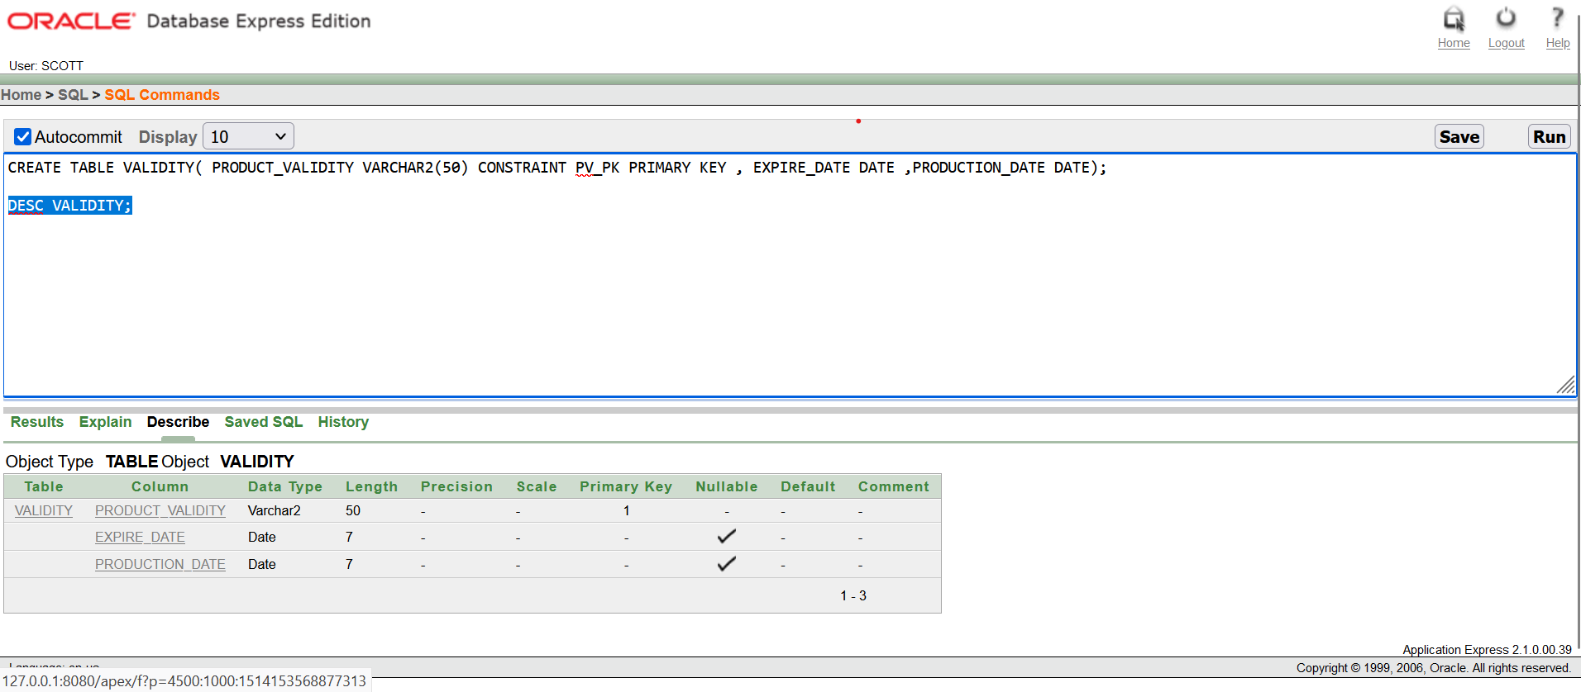

1. **CREATE TABLE STOCK(FLAVOR_NAME VARCHAR(12) CONSTRAINT FN_PK PRIMARY KEY, QUANTITY NUMBER(4) DEFAULT 0, TOTAL_PROFIT NUMBER (8) CONSTRAINT "TF_FK-1" REFERENCES PROFIT(TOTAL_PROFIT), PRODUCT_VALIDITY VARCHAR2(50) CONSTRAINT "PV_FK-2" REFERENCES VALIDITY (PRODUCT_VALIDITY), TREND_LICENSE NUMBER(8) CONSTRAINT "TL_FK-3" REFERENCES SHOP(TREND_LICENSE));** 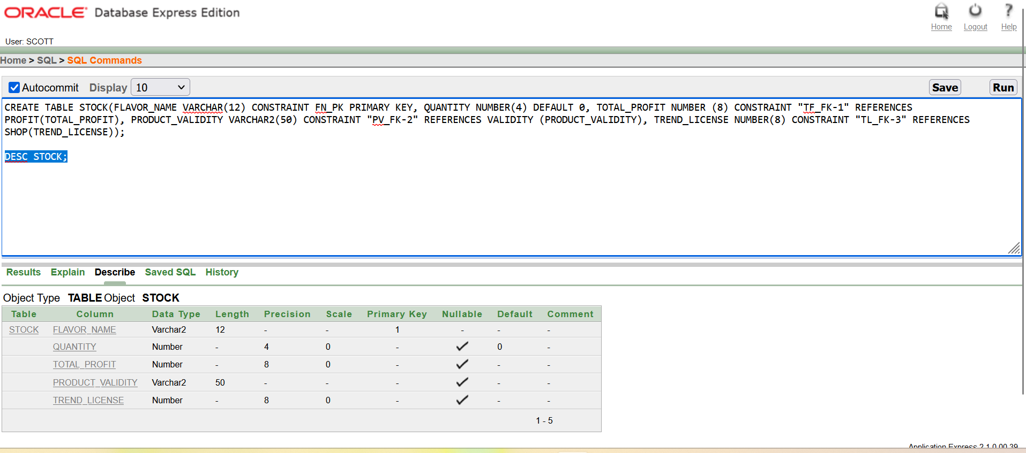
2. **CREATE TABLE ORDERS(OE_ID NUMBER(3) CONSTRAINT "OEID_PK>=100" PRIMARY KEY CHECK(OE_ID>=100),OWNER_ID NUMBER(4) CONSTRAINT OID_FK REFERENCES OWNER( OWNER_ID), EMPLOYEE_ID VARCHAR(10) CONSTRAINT EID_FK REFERENCES EMPLOYEE(EMPLOYEE_ID))**

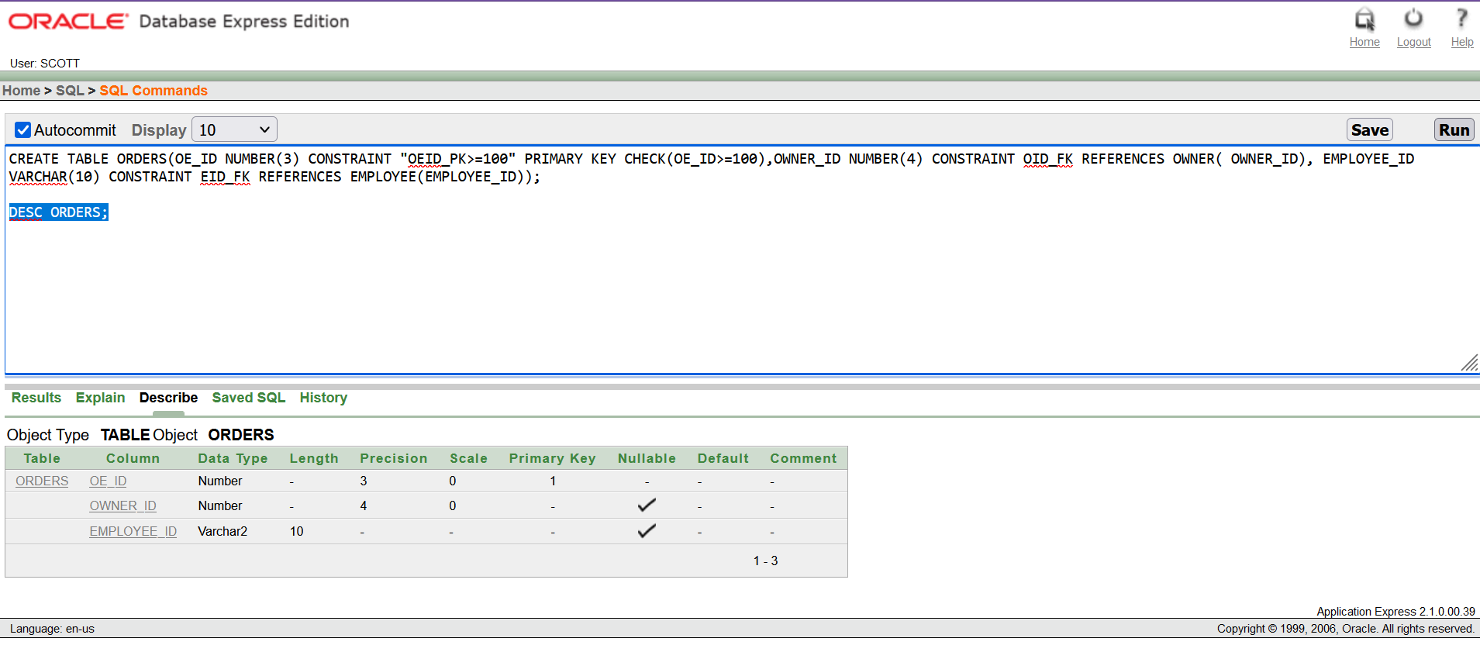

1. **CREATE TABLE EMPCHECK(ES_ID NUMBER(2) CONSTRAINT ES_ID_PK PRIMARY KEY,EMPLOYEE_ID VARCHAR(10) CONSTRAINT "EID_FK-1" REFERENCES EMPLOYEE(EMPLOYEE_ID),FLAVOR_NAME VARCHAR(12) CONSTRAINT FN_FK REFERENCES STOCK(FLAVOR_NAME))**

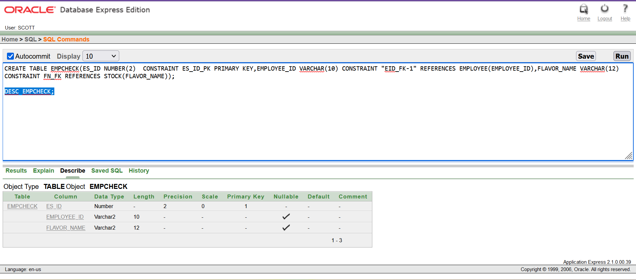

1. **CREATE TABLE BILL(BILL_NUMBER NUMBER(5) CONSTRAINT "BN_PK>=10000" PRIMARY KEY CHECK(BILL_NUMBER>=10000), TOTAL_AMOUNT NUMBER(4) NOT NULL, DATE_OF_PAYMENT DATE)**

1. **CREATE TABLE MEMBER(MEMBER_ID NUMBER(5) CONSTRAINT MID_PK PRIMARY KEY, CUSTOMER_NAME VARCHAR(25) NOT NULL, CUSTOMER_NUMBER VARCHAR(11) DEFAULT 0, BILL_NUMBER NUMBER(5),PAYED_BY NUMBER(5) CONSTRAINT BN_FK REFERENCES BILL(BILL_NUMBER),DOB DATE)**

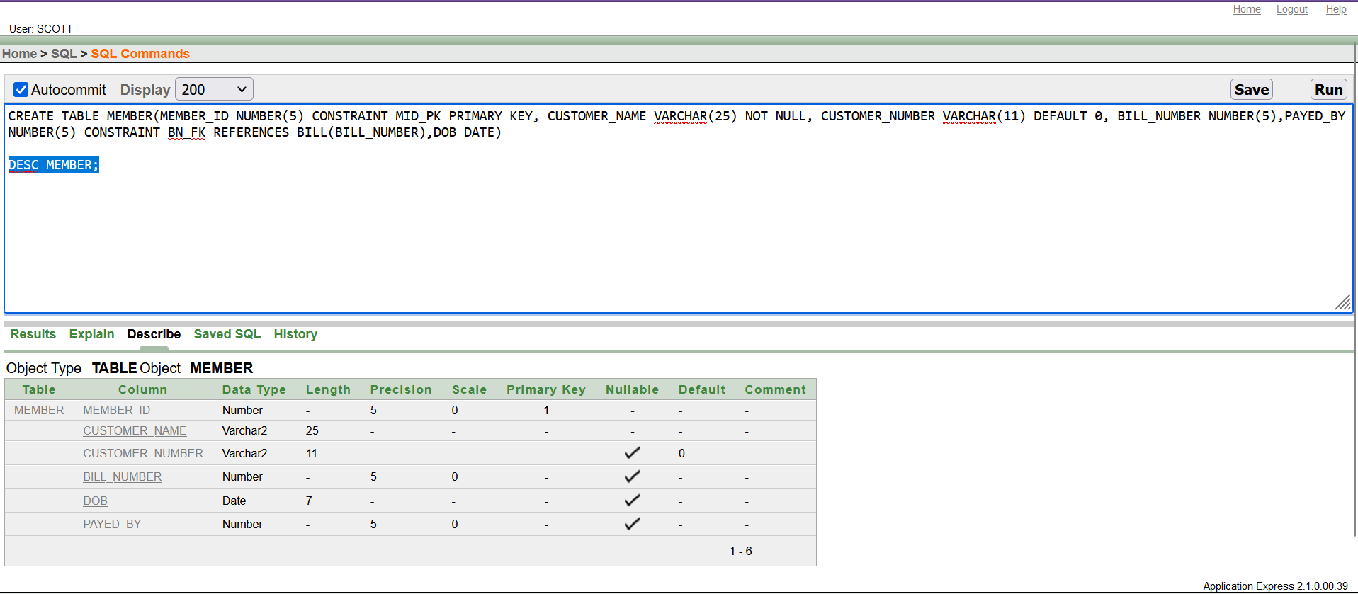

1. **CREATE TABLE MEMBERBROWS (MEMBER_ID NUMBER(5) CONSTRAINT "MID_PK-MB" PRIMARY KEY, CUSTOMER_NAME VARCHAR(25) NOT NULL, CUSTOMER_NUMBER VARCHAR(11) DEFAULT 0, SERIAL_NUMBER NUMBER(2) CONSTRAINT "SN_FK-M" REFERENCES MENU(SERIAL_NUMBER))**

1. **CREATE TABLE SERVICE(EM_ID NUMBER(2) CONSTRAINT EMID_PK PRIMARY KEY, EMPLOYEE_ID VARCHAR(10) CONSTRAINT "EID_FK-2" REFERENCES EMPLOYEE(EMPLOYEE_ID), MEMBER_ID NUMBER(5) CONSTRAINT "MID_FK-2" REFERENCES MEMBER(MEMBER_ID))**

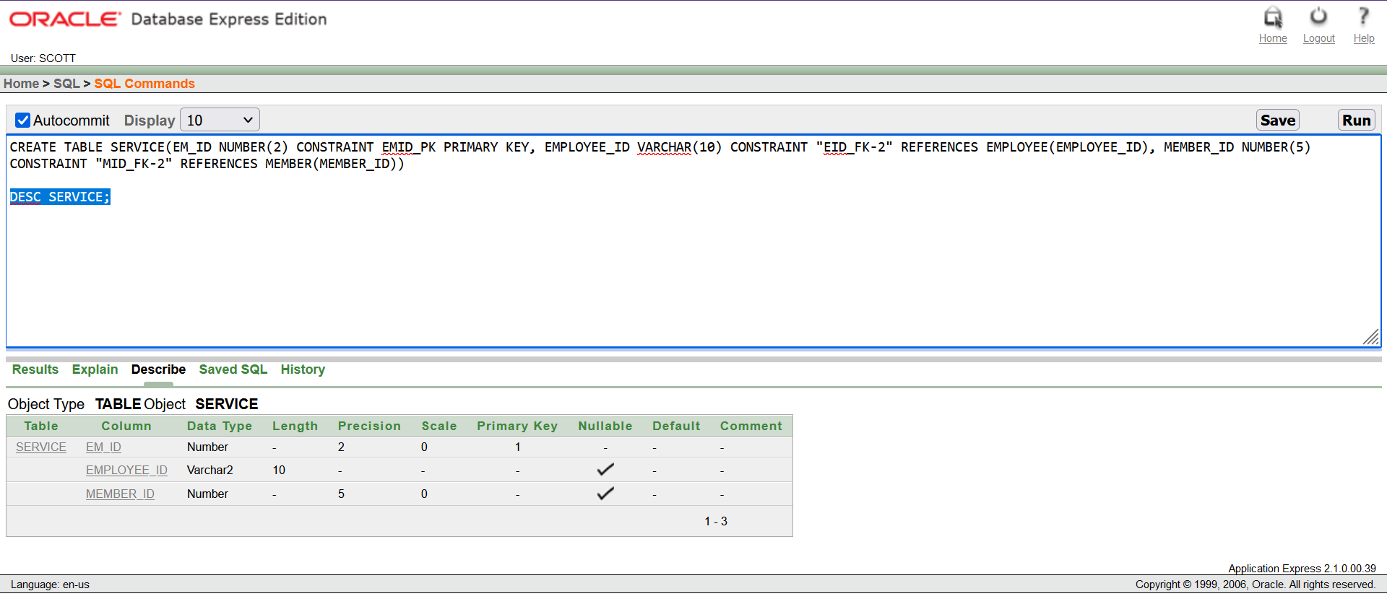

1. **CREATE TABLE MENU(SERIAL_NUMBER NUMBER(2) CONSTRAINT SN_PK PRIMARY KEY ,PRICE NUMBER(3) NOT NULL,FLAVOR_NAME VARCHAR(12) CONSTRAINT "FN_FK-2" REFERENCES STOCK(FLAVOR_NAME))**

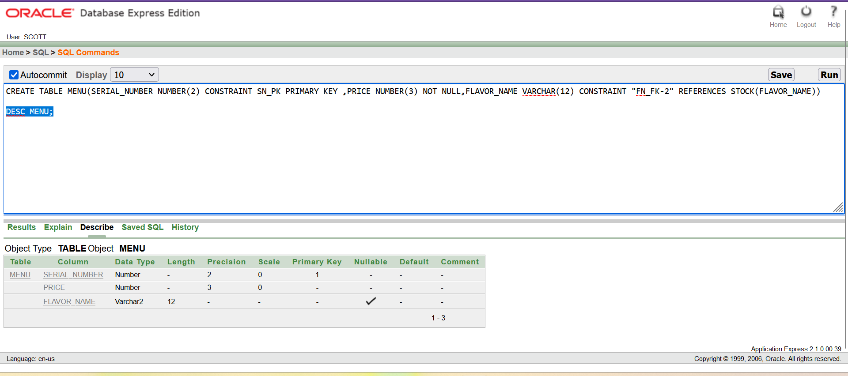

1. **CREATE TABLE JOB_LEVEL( JOB_ID NUMBER(3) CONSTRAINT JBID_PK PRIMARY KEY , JOB_LEVEL_NAME VARCHAR(20),JOB_SALARY NUMBER (8));**

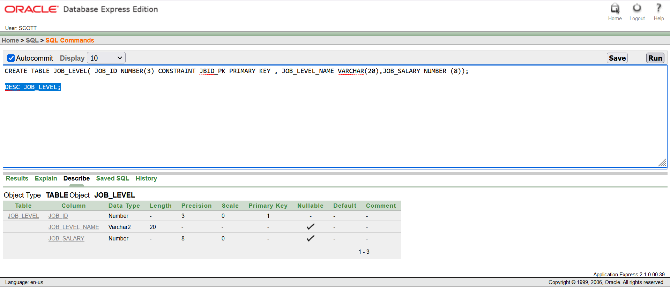

**Data Insertion :**

1. **Employee :**
2. INSERT INTO EMPLOYEE (MANAGER_ID) VALUES('15-45816-4') WHERE EMPLOYEE_ID = "15-45816-4"
3. INSERT INTO EMPLOYEE(EMPLOYEE_ID, EMPLOYEE_NAME, EMPLOYEE_SALARY, WORKING_PERIOD, JOIN_DATE,JOB_ID,TREND_LICENSE) VALUES ('10-45801-1', 'MD.JEWEL RANA', 500, 8, '10-JAN-10',101, 81692410)
4. INSERT INTO EMPLOYEE(EMPLOYEE_ID, EMPLOYEE_NAME, EMPLOYEE_SALARY, WORKING_PERIOD, JOIN_DATE,MANAGER_ID, JOB_ID, TREND_LICENSE) VALUES ('10-45802-2', 'MD.BIJOY HOSSEN', 1500, 9, '9-FEB-10','10-45801-1',103, 81692410)
5. INSERT INTO EMPLOYEE(EMPLOYEE_ID, EMPLOYEE_NAME, EMPLOYEE_SALARY, WORKING_PERIOD, JOIN_DATE,MANAGER_ID, JOB_ID, TREND_LICENSE) VALUES ('10-45803-3', 'MST. SANJIDA RAHMAN', 800, 7, '10-MAR-10','10-45801-1',107, 81692410)
6. INSERT INTO EMPLOYEE(EMPLOYEE_ID, EMPLOYEE_NAME, EMPLOYEE_SALARY, WORKING_PERIOD, JOIN_DATE,MANAGER_ID, JOB_ID, TREND_LICENSE) VALUES ('11-45804-4', 'MD.RONI AHAMED', 550, 8, '12-APR-11','11-45805-5',102, 81692411)
7. INSERT INTO EMPLOYEE(EMPLOYEE_ID, EMPLOYEE_NAME, EMPLOYEE_SALARY, WORKING_PERIOD, JOIN_DATE, JOB_ID, TREND_LICENSE) VALUES ('11-45805-5', 'MD.MEHADI ', 1600, 8, '16-MAY-11',101, 81692411)
8. INSERT INTO EMPLOYEE(EMPLOYEE_ID, EMPLOYEE_NAME, EMPLOYEE_SALARY, WORKING_PERIOD, JOIN_DATE,MANAGER_ID, JOB_ID, TREND_LICENSE) VALUES ('11-45806-6', 'NUR TOMAL', 800, 8, '24-JUN-11','11-45805-5', 110,81692411)
9. INSERT INTO EMPLOYEE(EMPLOYEE_ID, EMPLOYEE_NAME, EMPLOYEE_SALARY, WORKING_PERIOD, JOIN_DATE,MANAGER_ID, JOB_ID, TREND_LICENSE) VALUES ('12-45807-7', 'TOMAL CHOWDHURY', 400, 8, '01-JUL-12','12-45809-9', 105, 81692412)
10. INSERT INTO EMPLOYEE(EMPLOYEE_ID, EMPLOYEE_NAME, EMPLOYEE_SALARY, WORKING_PERIOD, JOIN_DATE,MANAGER_ID, JOB_ID, TREND_LICENSE) VALUES ('12-25808-8', 'SHANTO BISHAWS', 2500, 9, '10-AUG-12','12-45809-9',104, 81692412)
11. INSERT INTO EMPLOYEE(EMPLOYEE_ID, EMPLOYEE_NAME, EMPLOYEE_SALARY, WORKING_PERIOD, JOIN_DATE, JOB_ID, TREND_LICENSE) VALUES ('12-45809-9', 'EBRAHIM OMI', 500, 8, '10-SEP-12',101, 81692412)
12. INSERT INTO EMPLOYEE(EMPLOYEE_ID, EMPLOYEE_NAME, EMPLOYEE_SALARY, WORKING_PERIOD, JOIN_DATE, JOB_ID, TREND_LICENSE) VALUES ('13-5810-10', 'SHOGH ', 480, 8, '20-OCT-13', 101,81692413)
13. INSERT INTO EMPLOYEE(EMPLOYEE_ID, EMPLOYEE_NAME, EMPLOYEE_SALARY, WORKING_PERIOD, JOIN_DATE,MANAGER_ID, JOB_ID, TREND_LICENSE) VALUES ('13-5811-11', 'AFSANA ONU', 1640,6, '16-NOV-13','13-5810-10',109, 81692413)
14. INSERT INTO EMPLOYEE(EMPLOYEE_ID, EMPLOYEE_NAME, EMPLOYEE_SALARY, WORKING_PERIOD, JOIN_DATE,MANAGER_ID, JOB_ID, TREND_LICENSE) VALUES ('13-5812-12', 'REZWANUL KABIR', 600, 8, '14-DEC-13','13-5810-10',105, 81692413)
15. INSERT INTO EMPLOYEE(EMPLOYEE_ID, EMPLOYEE_NAME, EMPLOYEE_SALARY, WORKING_PERIOD, JOIN_DATE,MANAGER_ID, JOB_ID, TREND_LICENSE) VALUES ('14-45813-1', 'MEHEDI HASAN MAMUN', 700, 8, '10-JAN-14','14-45814-2',102, 81692414)
16. INSERT INTO EMPLOYEE(EMPLOYEE_ID, EMPLOYEE_NAME, EMPLOYEE_SALARY, WORKING_PERIOD, JOIN_DATE, JOB_ID, TREND_LICENSE) VALUES ('14-45814-2', 'ASHIKUL ISLAM FAISAL', 2467, 7, '10-FEB-14',101, 81692414)
17. INSERT INTO EMPLOYEE(EMPLOYEE_ID, EMPLOYEE_NAME, EMPLOYEE_SALARY, WORKING_PERIOD, JOIN_DATE,MANAGER_ID, JOB_ID, TREND_LICENSE) VALUES ('14-45815-3', 'YEASIN NEWAZ', 1358, 8, '5-MAR-14','14-45814-2', 107, 81692414)
18. INSERT INTO EMPLOYEE(EMPLOYEE_ID, EMPLOYEE_NAME, EMPLOYEE_SALARY, WORKING_PERIOD, JOIN_DATE, JOB_ID, TREND_LICENSE) VALUES ('15-45816-4', 'MUSFIKUR RAHMAN MUIN', 4577, 8, '3-APR-15',101, 81692415)
19. INSERT INTO EMPLOYEE(EMPLOYEE_ID, EMPLOYEE_NAME, EMPLOYEE_SALARY, WORKING_PERIOD, JOIN_DATE,MANAGER_ID, JOB_ID, TREND_LICENSE) VALUES ('15-55817-5', 'SAIMUZZAMAN SAKIB', 453, 9, '24-MAY-15','15-45816-4',110, 81692415)
20. INSERT INTO EMPLOYEE(EMPLOYEE_ID, EMPLOYEE_NAME, EMPLOYEE_SALARY, WORKING_PERIOD, JOIN_DATE,MANAGER_ID, JOB_ID, TREND_LICENSE) VALUES ('15-45818-6', 'NAFIUN OVI', 350, 10, '26-JUN-15', '15-45816-4', 102,81692415)

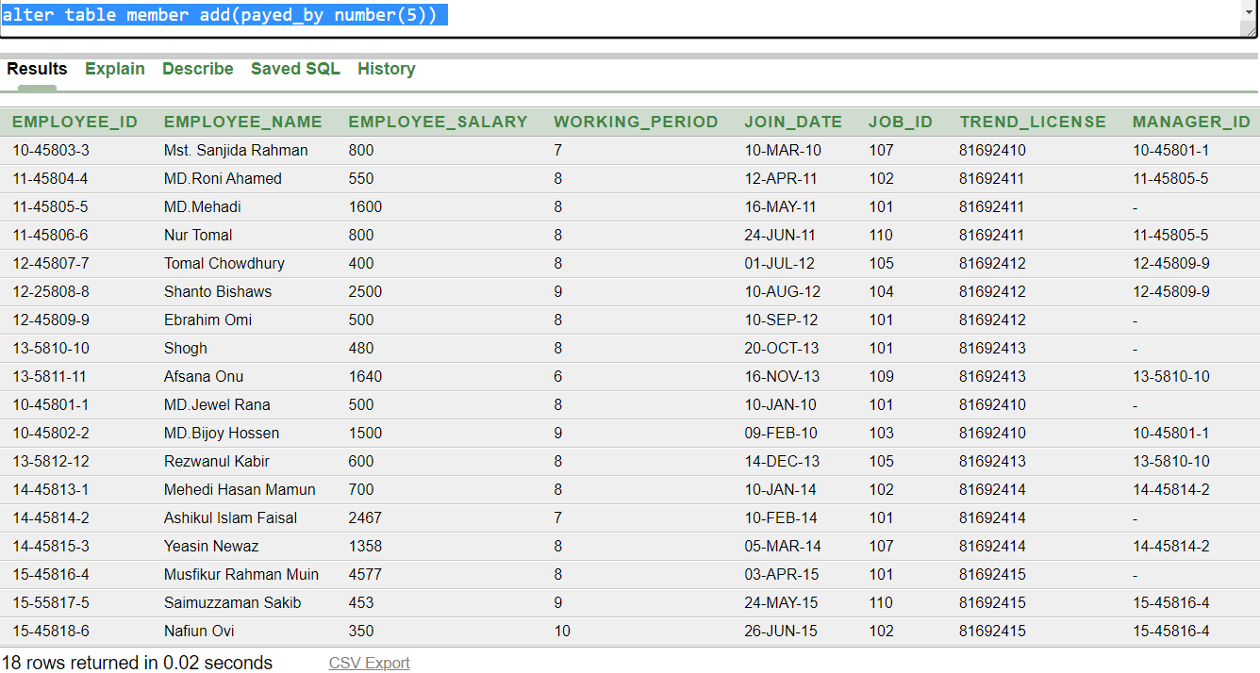

**2. Shop :**

1. INSERT INTO SHOP (TREND_LICENSE,SHOP_NAME,HOT_NUMBER,LOCATION) VALUES (81692410,'THE SWEET COURSE',09612216656,'BONANNI')
2. INSERT INTO SHOP (TREND_LICENSE,SHOP_NAME,HOT_NUMBER,LOCATION) VALUES (81692411,'SCOOPS OF DELIGHT',09612216666,'GULSHAN')
3. INSERT INTO SHOP (TREND_LICENSE,SHOP_NAME,HOT_NUMBER,LOCATION) VALUES (81692412,'SUGAR RUSH CONES',09612216676,'DHANMONDI')
4. INSERT INTO SHOP (TREND_LICENSE,SHOP_NAME,HOT_NUMBER,LOCATION) VALUES (81692413,'ICY VANILLA MOON',09612216686,'MIRPUR')
5. INSERT INTO SHOP (TREND_LICENSE,SHOP_NAME,HOT_NUMBER,LOCATION) VALUES (81692414,'FANTASY SCOOP',09612216696,'UTTORA')
6. INSERT INTO SHOP (TREND_LICENSE,SHOP_NAME,HOT_NUMBER,LOCATION) VALUES (81692415,'FROSTY DREAM',09612216556,'MUHAMMADPUR')
7. INSERT INTO SHOP (TREND_LICENSE,SHOP_NAME,HOT_NUMBER,LOCATION) VALUES (81692416,'ICE CREAM ALLEY',09612216646,'BASHUNDHORA')
8. INSERT INTO SHOP (TREND_LICENSE,SHOP_NAME,HOT_NUMBER,LOCATION) VALUES (81692417,'CHILLED BITES PARLOR',09612216756,'SAVAR')
9. INSERT INTO SHOP (TREND_LICENSE,SHOP_NAME,HOT_NUMBER,LOCATION) VALUES (81692418,'CHILLED BITES',09612216856,'GAZIPUR')
10. INSERT INTO SHOP (TREND_LICENSE,SHOP_NAME,HOT_NUMBER,LOCATION) VALUES (81692419,'BANANA SPLIT TOWN',09612216956,'RANGPUR')

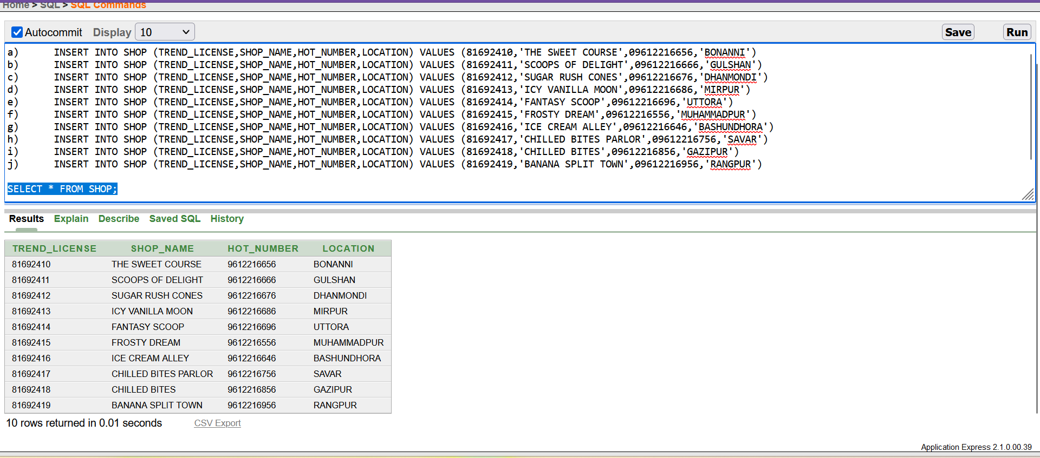

**3. Owner :**

a) INSERT INTO OWNER(OWNER_ID ,OWNER_NAME , CONTACT_NUMBER , TREND_LICENSE) VALUES (1001, 'TAUHID', 12345611, 81692410)

b) INSERT INTO OWNER(OWNER_ID ,OWNER_NAME , CONTACT_NUMBER , TREND_LICENSE) VALUES (1002, 'HASAN', 12345612, 81692411)

c) INSERT INTO OWNER(OWNER_ID ,OWNER_NAME , CONTACT_NUMBER , TREND_LICENSE) VALUES (1003, 'MAAHI', 12345613, 81692412)

d) INSERT INTO OWNER(OWNER_ID ,OWNER_NAME , CONTACT_NUMBER , TREND_LICENSE) VALUES (1004, 'JHOTHIR', 12345614, 81692413)

e) INSERT INTO OWNER(OWNER_ID ,OWNER_NAME , CONTACT_NUMBER , TREND_LICENSE) VALUES (1005, 'SARKER', 12345615, 81692414)

f) INSERT INTO OWNER(OWNER_ID ,OWNER_NAME , CONTACT_NUMBER , TREND_LICENSE) VALUES (1006, 'EMON', 12345616, 81692415)

g) INSERT INTO OWNER(OWNER_ID ,OWNER_NAME , CONTACT_NUMBER , TREND_LICENSE) VALUES (1007, 'NURE', 12345617, 81692416)

h) INSERT INTO OWNER(OWNER_ID ,OWNER_NAME , CONTACT_NUMBER , TREND_LICENSE) VALUES (1008, 'ALOM', 12345618, 81692417)

i) INSERT INTO OWNER(OWNER_ID ,OWNER_NAME , CONTACT_NUMBER , TREND_LICENSE) VALUES (1009, 'JNAMS', 12345619, 81692418)

j) INSERT INTO OWNER(OWNER_ID ,OWNER_NAME , CONTACT_NUMBER , TREND_LICENSE) VALUES (1010, 'SAMI', 12345667, 81692419)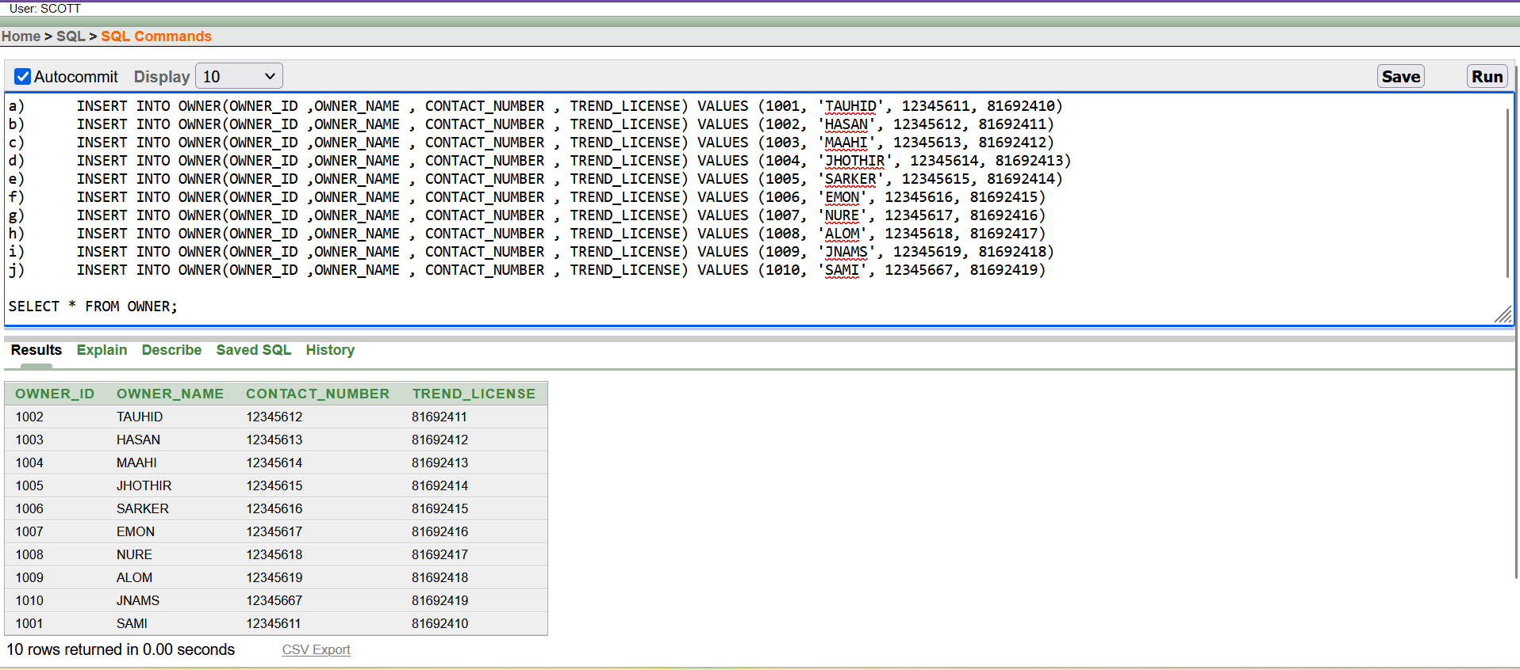

**4. Profit :**

1. INSERT INTO PROFIT(TOTAL_PROFIT, BUYING_PRICE, SELLING_PRICE ) VALUES (100,200,300)
2. INSERT INTO PROFIT(TOTAL_PROFIT, BUYING_PRICE, SELLING_PRICE ) VALUES (50,150,250)
3. INSERT INTO PROFIT(TOTAL_PROFIT, BUYING_PRICE, SELLING_PRICE ) VALUES (40,140,260)
4. INSERT INTO PROFIT(TOTAL_PROFIT, BUYING_PRICE, SELLING_PRICE ) VALUES (150,300,450)
5. INSERT INTO PROFIT(TOTAL_PROFIT, BUYING_PRICE, SELLING_PRICE ) VALUES (200,260,460)
6. INSERT INTO PROFIT(TOTAL_PROFIT, BUYING_PRICE, SELLING_PRICE ) VALUES (300,400,700)
7. INSERT INTO PROFIT(TOTAL_PROFIT, BUYING_PRICE, SELLING_PRICE ) VALUES (10,20,30)
8. INSERT INTO PROFIT(TOTAL_PROFIT, BUYING_PRICE, SELLING_PRICE ) VALUES (20,30,50)
9. INSERT INTO PROFIT(TOTAL_PROFIT, BUYING_PRICE, SELLING_PRICE ) VALUES (30,40,70)
10. INSERT INTO PROFIT(TOTAL_PROFIT, BUYING_PRICE, SELLING_PRICE ) VALUES (110,210,320)

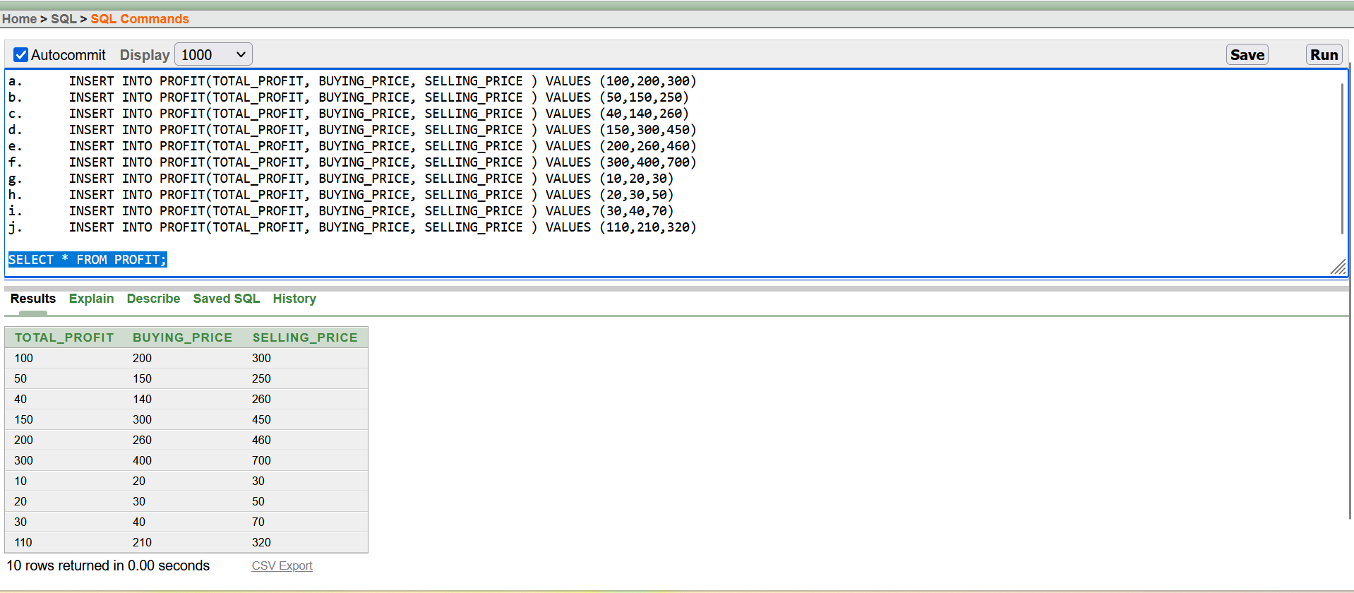

**5. Validity :**

1. INSERT INTO VALIDITY(PRODUCT_VALIDITY , EXPIRE_DATE ,PRODUCTION_DATE) VALUES ('7 MONTH','30-JULY-21','1-JAN-21')
2. INSERT INTO VALIDITY(PRODUCT_VALIDITY , EXPIRE_DATE ,PRODUCTION_DATE) VALUES ('6 MONTH','30-JUN-22','1-JAN-22')
3. INSERT INTO VALIDITY(PRODUCT_VALIDITY , EXPIRE_DATE ,PRODUCTION_DATE) VALUES ('3 MONTH','30-MARCH-22','1-JAN-22')
4. INSERT INTO VALIDITY(PRODUCT_VALIDITY , EXPIRE_DATE ,PRODUCTION_DATE) VALUES ('4 MONTH','30-APRIL-22','1-JAN-22')
5. INSERT INTO VALIDITY(PRODUCT_VALIDITY , EXPIRE_DATE ,PRODUCTION_DATE) VALUES ('5 MONTH','30-MAY-22','1-JAN-22')
6. INSERT INTO VALIDITY(PRODUCT_VALIDITY , EXPIRE_DATE ,PRODUCTION_DATE) VALUES ('1 YEAR','31-DEC-22','1-JAN-22')
7. INSERT INTO VALIDITY(PRODUCT_VALIDITY , EXPIRE_DATE ,PRODUCTION_DATE) VALUES ('2 YEAR','31-DEC-23','1-JAN-22')
8. INSERT INTO VALIDITY(PRODUCT_VALIDITY , EXPIRE_DATE ,PRODUCTION_DATE) VALUES ('9 MONTH','30-AUG-22','1-JAN-22')
9. INSERT INTO VALIDITY(PRODUCT_VALIDITY , EXPIRE_DATE ,PRODUCTION_DATE) VALUES ('10 MONTH','30-OCT-22','1-JAN-22')
10. INSERT INTO VALIDITY(PRODUCT_VALIDITY , EXPIRE_DATE ,PRODUCTION_DATE) VALUES ('11 MONTH','30-NOV-22','1-JAN-22')

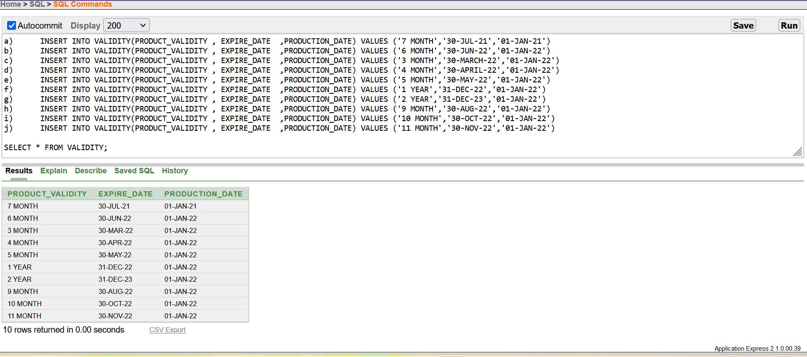

**6. Stock :**

1. INSERT INTO STOCK(FLAVOR_NAME , QUANTITY, TOTAL_PROFIT, PRODUCT_VALIDITY , TREND_LICENSE ) VALUES ('COOKIESCREM',100,100,'7 MONTH',81692410)
2. INSERT INTO STOCK(FLAVOR_NAME , QUANTITY, TOTAL_PROFIT, PRODUCT_VALIDITY , TREND_LICENSE ) VALUES ('CHOCOLATE',90,50,'6 MONTH',81692411)
3. INSERT INTO STOCK(FLAVOR_NAME , QUANTITY, TOTAL_PROFIT, PRODUCT_VALIDITY , TREND_LICENSE ) VALUES ('VANILLA',80,40,'3 MONTH',81692412)
4. INSERT INTO STOCK(FLAVOR_NAME , QUANTITY, TOTAL_PROFIT, PRODUCT_VALIDITY , TREND_LICENSE ) VALUES ('MINTCHOKLATE',70,150,'4 MONTH',81692413)
5. INSERT INTO STOCK(FLAVOR_NAME , QUANTITY, TOTAL_PROFIT, PRODUCT_VALIDITY , TREND_LICENSE ) VALUES ('CHOLATECHIP',60,200,'5 MONTH',81692414)
6. INSERT INTO STOCK(FLAVOR_NAME , QUANTITY, TOTAL_PROFIT, PRODUCT_VALIDITY , TREND_LICENSE ) VALUES ('STRAWBERRY',50,300,'1 YEAR',81692415)
7. INSERT INTO STOCK(FLAVOR_NAME , QUANTITY, TOTAL_PROFIT, PRODUCT_VALIDITY , TREND_LICENSE ) VALUES ('FRENCHVANILA',10,100,'2 YEAR',81692416)
8. INSERT INTO STOCK(FLAVOR_NAME , QUANTITY, TOTAL_PROFIT, PRODUCT_VALIDITY , TREND_LICENSE ) VALUES ('ROCKY ROAD',30,20,'9 MONTH',81692417)
9. INSERT INTO STOCK(FLAVOR_NAME , QUANTITY, TOTAL_PROFIT, PRODUCT_VALIDITY , TREND_LICENSE ) VALUES ('BUTTER PECAN',110,30,'10 MONTH',81692418)
10. INSERT INTO STOCK(FLAVOR_NAME , QUANTITY, TOTAL_PROFIT, PRODUCT_VALIDITY , TREND_LICENSE ) VALUES ('MOCHA',120,110,'11 MONTH',81692419)

**7. Orders :**

1. INSERT INTO ORDERS(OE_ID ,OWNER_ID , EMPLOYEE_ID ) VALUES (101,1000,'10-45801-1')
2. INSERT INTO ORDERS(OE_ID ,OWNER_ID , EMPLOYEE_ID ) VALUES (102,1001,'11-45804-4')
3. INSERT INTO ORDERS(OE_ID ,OWNER_ID , EMPLOYEE_ID ) VALUES (103,1002,'12-45807-7')
4. INSERT INTO ORDERS(OE_ID ,OWNER_ID , EMPLOYEE_ID ) VALUES (104,1003,'13-5810-10')
5. INSERT INTO ORDERS(OE_ID ,OWNER_ID , EMPLOYEE_ID ) VALUES (105,1004,'14-45813-1')
6. INSERT INTO ORDERS(OE_ID ,OWNER_ID , EMPLOYEE_ID ) VALUES (106,1005,'15-45816-4')
7. INSERT INTO ORDERS(OE_ID ,OWNER_ID , EMPLOYEE_ID ) VALUES (107,1006,'11-45806-6')
8. INSERT INTO ORDERS(OE_ID ,OWNER_ID , EMPLOYEE_ID ) VALUES (108,1007,'12-45809-9')
9. INSERT INTO ORDERS(OE_ID ,OWNER_ID , EMPLOYEE_ID ) VALUES (109,1008,'10-45802-2')
10. INSERT INTO ORDERS(OE_ID ,OWNER_ID , EMPLOYEE_ID ) VALUES (110,1009,'10-45803-3')

**8. EmpCheck :**

1. INSERT INTO EMPCHECK(ES_ID,EMPLOYEE_ID ,FLAVOR_NAME ) VALUES (20,'10-45801-1','COOKIESCREM')
2. INSERT INTO EMPCHECK(ES_ID,EMPLOYEE_ID ,FLAVOR_NAME ) VALUES (21,'11-45804-4','CHOCOLATE')
3. INSERT INTO EMPCHECK(ES_ID,EMPLOYEE_ID ,FLAVOR_NAME ) VALUES (22,'12-45807-7','VANILLA')
4. INSERT INTO EMPCHECK(ES_ID,EMPLOYEE_ID ,FLAVOR_NAME ) VALUES (23,'13-5810-10','MINTCHOKLATE')
5. INSERT INTO EMPCHECK(ES_ID,EMPLOYEE_ID ,FLAVOR_NAME ) VALUES (24,'14-45813-1','CHOLATECHIP')
6. INSERT INTO EMPCHECK(ES_ID,EMPLOYEE_ID ,FLAVOR_NAME ) VALUES (25,'15-45816-4','STRAWBERRY')
7. INSERT INTO EMPCHECK(ES_ID,EMPLOYEE_ID ,FLAVOR_NAME ) VALUES (26,'11-45806-6','FRENCHVANILA')
8. INSERT INTO EMPCHECK(ES_ID,EMPLOYEE_ID ,FLAVOR_NAME ) VALUES (27,'12-45809-9','ROCKY ROAD')
9. INSERT INTO EMPCHECK(ES_ID,EMPLOYEE_ID ,FLAVOR_NAME ) VALUES (28,'10-45802-2','BUTTER PECAN')
10. INSERT INTO EMPCHECK(ES_ID,EMPLOYEE_ID ,FLAVOR_NAME ) VALUES (29,'10-45803-3','MOCHA')

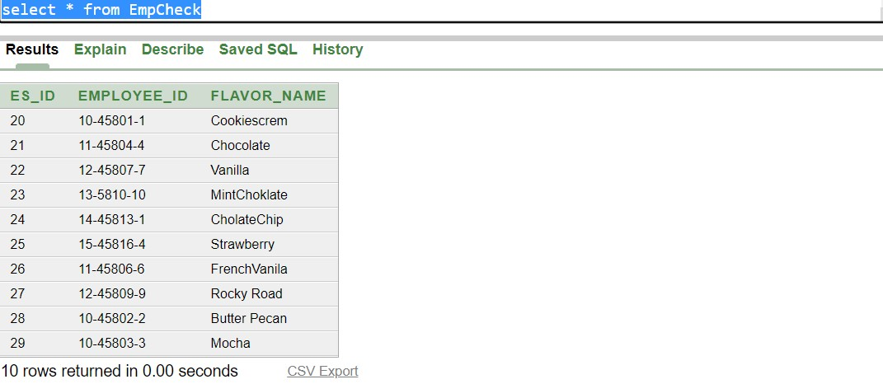

**9. Bill :**

1. INSERT INTO BILL(BILL_NUMBER,TOTAL_AMOUNT ,DATE_OF_PAYMENT) VALUES (10000,200,'2-APRIL-22')
2. INSERT INTO BILL(BILL_NUMBER,TOTAL_AMOUNT ,DATE_OF_PAYMENT) VALUES (10001,400,'2-MAY-22')
3. INSERT INTO BILL(BILL_NUMBER,TOTAL_AMOUNT ,DATE_OF_PAYMENT) VALUES (10002,500,'2-JUNE-22')
4. INSERT INTO BILL(BILL_NUMBER,TOTAL_AMOUNT ,DATE_OF_PAYMENT) VALUES (10003,600,'3-APRIL-22')
5. INSERT INTO BILL(BILL_NUMBER,TOTAL_AMOUNT ,DATE_OF_PAYMENT) VALUES (10004,500,'5-APRIL-22')
6. INSERT INTO BILL(BILL_NUMBER,TOTAL_AMOUNT ,DATE_OF_PAYMENT) VALUES (10005,900,'4-APRIL-22')
7. INSERT INTO BILL(BILL_NUMBER,TOTAL_AMOUNT ,DATE_OF_PAYMENT) VALUES (10006,200,'5-MAY-22')
8. INSERT INTO BILL(BILL_NUMBER,TOTAL_AMOUNT ,DATE_OF_PAYMENT) VALUES (10007,1100,'9-MAY-22')
9. INSERT INTO BILL(BILL_NUMBER,TOTAL_AMOUNT ,DATE_OF_PAYMENT) VALUES (10008,700,'11-MAY-22')
10. INSERT INTO BILL(BILL_NUMBER,TOTAL_AMOUNT ,DATE_OF_PAYMENT) VALUES (10009,800,'22-JUNE-22')

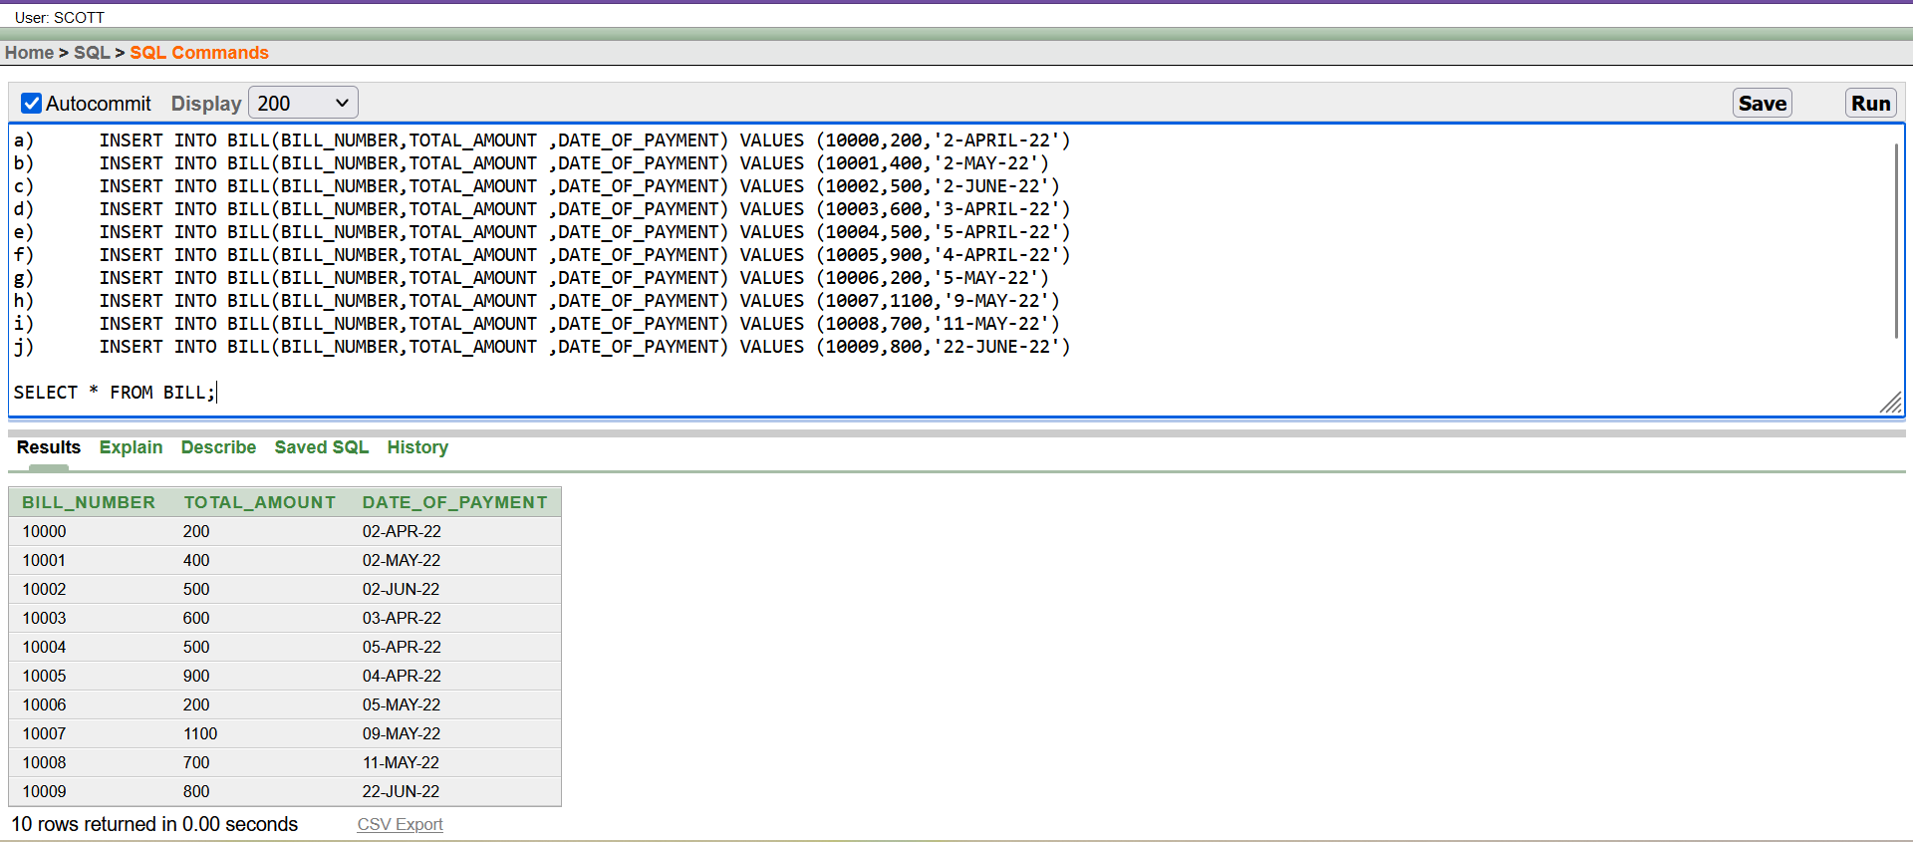

**10 . Member :**

1. INSERT INTO MEMBER(MEMBER_ID,CUSTOMER_NAME,CUSTOMER_NUMBER,BILL_NUMBER,PAYED_BY,DOB) VALUES (101,'NURA ALAM',01790336868,10000,101, 23-JAN-99)
2. INSERT INTO MEMBER(MEMBER_ID,CUSTOMER_NAME,CUSTOMER_NUMBER,BILL_NUMBER,PAYED_BY, DOB) VALUES (102,'AIFF HOSSAIN',01790336868,10008,106, 03-JUL-01)
3. INSERT INTO MEMBER(MEMBER_ID,CUSTOMER_NAME,CUSTOMER_NUMBER,BILL_NUMBER,PAYED_BY, DOB) VALUES (103,'MAHENDRA BAHUBALI',01790336868,10009,105, 12-FEB-02)
4. INSERT INTO MEMBER(MEMBER_ID,CUSTOMER_NAME,CUSTOMER_NUMBER,BILL_NUMBER,PAYED_BY, DOB) VALUES (104,'KATTAPA CHOWDHURY',01790336868,10001,109, 01-DEC-71)
5. INSERT INTO MEMBER(MEMBER_ID,CUSTOMER_NAME,CUSTOMER_NUMBER,BILL_NUMBER,PAYED_BY) VALUES (105,'TAMIM IQBAL',01790336868,10002,101)
6. INSERT INTO MEMBER(MEMBER_ID,CUSTOMER_NAME,CUSTOMER_NUMBER,BILL_NUMBER,PAYED_BY, DOB) VALUES (106,'SHAKIB AL HASAN',01790336868,10003,100, 25-SEP-89)
7. INSERT INTO MEMBER(MEMBER_ID,CUSTOMER_NAME,CUSTOMER_NUMBER,BILL_NUMBER,PAYED_BY, DOB) VALUES (107,'ANAMUL HAQUE BIJOY',01790336868,10004,104, 13-NOV-61)
8. INSERT INTO MEMBER(MEMBER_ID,CUSTOMER_NAME,CUSTOMER_NUMBER,BILL_NUMBER,PAYED_BY, DOB) VALUES (108,'NASUM AHAMD',01790336868,10005,108, 07-OCT-09)
9. INSERT INTO MEMBER(MEMBER_ID,CUSTOMER_NAME,CUSTOMER_NUMBER,BILL_NUMBER,PAYED_BY) VALUES (109,'LITON DAS',01790336868,10006,109)
10. INSERT INTO MEMBER(MEMBER_ID,CUSTOMER_NAME,CUSTOMER_NUMBER,BILL_NUMBER,PAYED_BY, DOB) VALUES (100,'LORD SHANTO',01790336868,10007,101, 09-JAN-99)

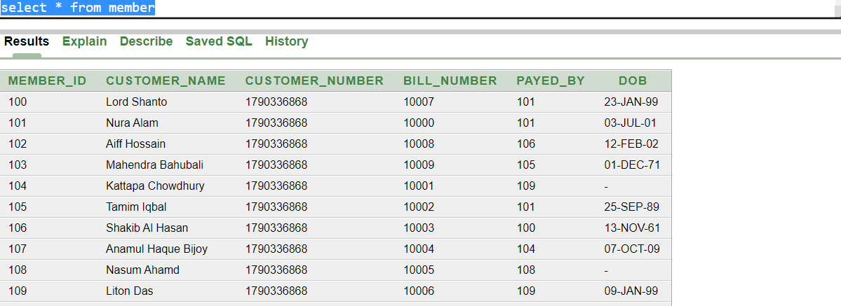

**11. MemberBrows :**

1. INSERT INTO MEMBERBROWS (MEMBER_ID , CUSTOMER_NAME , CUSTOMER_NUMBER , SERIAL_NUMBER ) VALUES (100,'SOHAN','100001',1)
2. INSERT INTO MEMBERBROWS (MEMBER_ID , CUSTOMER_NAME , CUSTOMER_NUMBER , SERIAL_NUMBER ) VALUES (101,'RIDOY',100002,2)
3. INSERT INTO MEMBERBROWS (MEMBER_ID , CUSTOMER_NAME , CUSTOMER_NUMBER , SERIAL_NUMBER ) VALUES (102,'JUBAYER',100003,3)
4. INSERT INTO MEMBERBROWS (MEMBER_ID , CUSTOMER_NAME , CUSTOMER_NUMBER , SERIAL_NUMBER ) VALUES (103,'SABBU',100004,4)
5. INSERT INTO MEMBERBROWS (MEMBER_ID , CUSTOMER_NAME , CUSTOMER_NUMBER , SERIAL_NUMBER ) VALUES (104,'SOHEL',100005,5)
6. INSERT INTO MEMBERBROWS (MEMBER_ID , CUSTOMER_NAME , CUSTOMER_NUMBER , SERIAL_NUMBER ) VALUES (105,'IMRAN',100006,6)
7. INSERT INTO MEMBERBROWS (MEMBER_ID , CUSTOMER_NAME , CUSTOMER_NUMBER , SERIAL_NUMBER ) VALUES (106,'RATUL',100007,7)
8. INSERT INTO MEMBERBROWS (MEMBER_ID , CUSTOMER_NAME , CUSTOMER_NUMBER , SERIAL_NUMBER ) VALUES (107,'RIFAT',100008,8)
9. INSERT INTO MEMBERBROWS (MEMBER_ID , CUSTOMER_NAME , CUSTOMER_NUMBER , SERIAL_NUMBER ) VALUES (108,'BIPUL',100009,9)
10. INSERT INTO MEMBERBROWS (MEMBER_ID , CUSTOMER_NAME , CUSTOMER_NUMBER , SERIAL_NUMBER ) VALUES (109,'BIPLOP',100010,10)

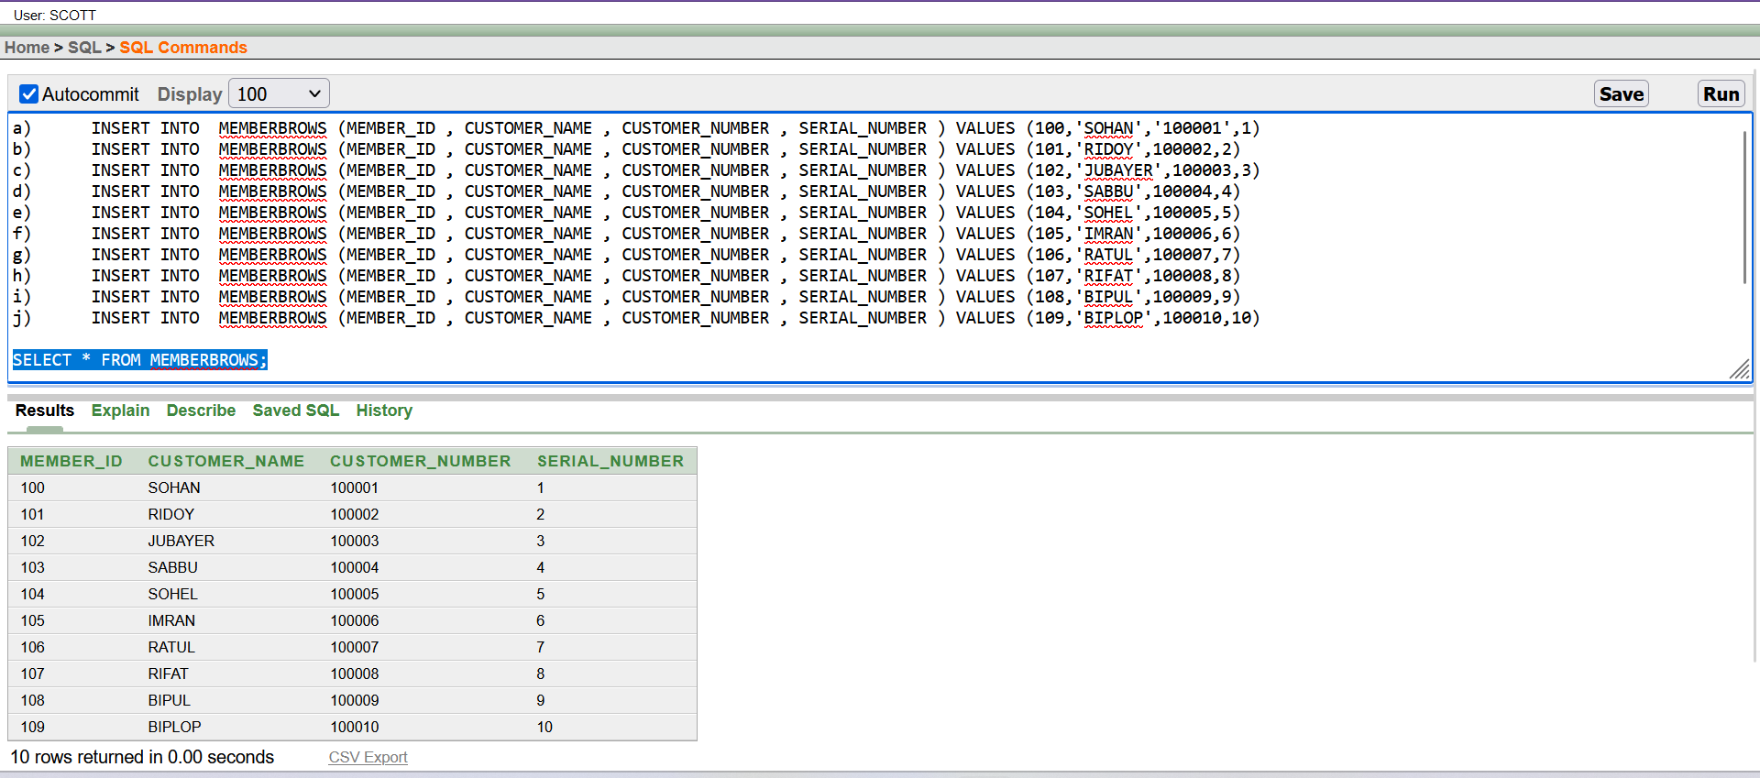

**12. Service :**

1. INSERT INTO SERVICE(EM_ID , EMPLOYEE_ID , MEMBER_ID ) VALUES (30,'10-45801-1',100)
2. INSERT INTO SERVICE(EM_ID , EMPLOYEE_ID , MEMBER_ID ) VALUES (31,'11-45804-4',101)
3. INSERT INTO SERVICE(EM_ID , EMPLOYEE_ID , MEMBER_ID ) VALUES (32,'12-45807-7',102)
4. INSERT INTO SERVICE(EM_ID , EMPLOYEE_ID , MEMBER_ID ) VALUES (33,'13-5810-10',103)
5. INSERT INTO SERVICE(EM_ID , EMPLOYEE_ID , MEMBER_ID ) VALUES (34,'14-45813-1',104)
6. INSERT INTO SERVICE(EM_ID , EMPLOYEE_ID , MEMBER_ID ) VALUES (35,'15-45816-4',105)
7. INSERT INTO SERVICE(EM_ID , EMPLOYEE_ID , MEMBER_ID ) VALUES (36,'11-45806-6',106)
8. INSERT INTO SERVICE(EM_ID , EMPLOYEE_ID , MEMBER_ID ) VALUES (37,'12-45809-9',107)
9. INSERT INTO SERVICE(EM_ID , EMPLOYEE_ID , MEMBER_ID ) VALUES (38,'10-45802-2',108)
10. INSERT INTO SERVICE(EM_ID , EMPLOYEE_ID , MEMBER_ID ) VALUES (39,'10-45803-3',109)

**13. Menu :**

1. INSERT INTO MENU(SERIAL_NUMBER ,PRICE ,FLAVOR_NAME ) VALUES (1,300,'COOKIESCREM')
2. INSERT INTO MENU(SERIAL_NUMBER ,PRICE ,FLAVOR_NAME ) VALUES (2,250,'CHOCOLATE')
3. INSERT INTO MENU(SERIAL_NUMBER ,PRICE ,FLAVOR_NAME ) VALUES (3,260,'VANILLA')
4. INSERT INTO MENU(SERIAL_NUMBER ,PRICE ,FLAVOR_NAME ) VALUES (4,450,'MINTCHOKLATE')
5. INSERT INTO MENU(SERIAL_NUMBER ,PRICE ,FLAVOR_NAME ) VALUES (5,460,'CHOLATECHIP')
6. INSERT INTO MENU(SERIAL_NUMBER ,PRICE ,FLAVOR_NAME ) VALUES (6,700,'STRAWBERRY')
7. INSERT INTO MENU(SERIAL_NUMBER ,PRICE ,FLAVOR_NAME ) VALUES (7,30,'FRENCHVANILA')
8. INSERT INTO MENU(SERIAL_NUMBER ,PRICE ,FLAVOR_NAME ) VALUES (8,50,'ROCKY ROAD')
9. INSERT INTO MENU(SERIAL_NUMBER ,PRICE ,FLAVOR_NAME ) VALUES (9,70,'BUTTER PECAN')
10. INSERT INTO MENU(SERIAL_NUMBER ,PRICE ,FLAVOR_NAME ) VALUES (10,320,'MOCHA')

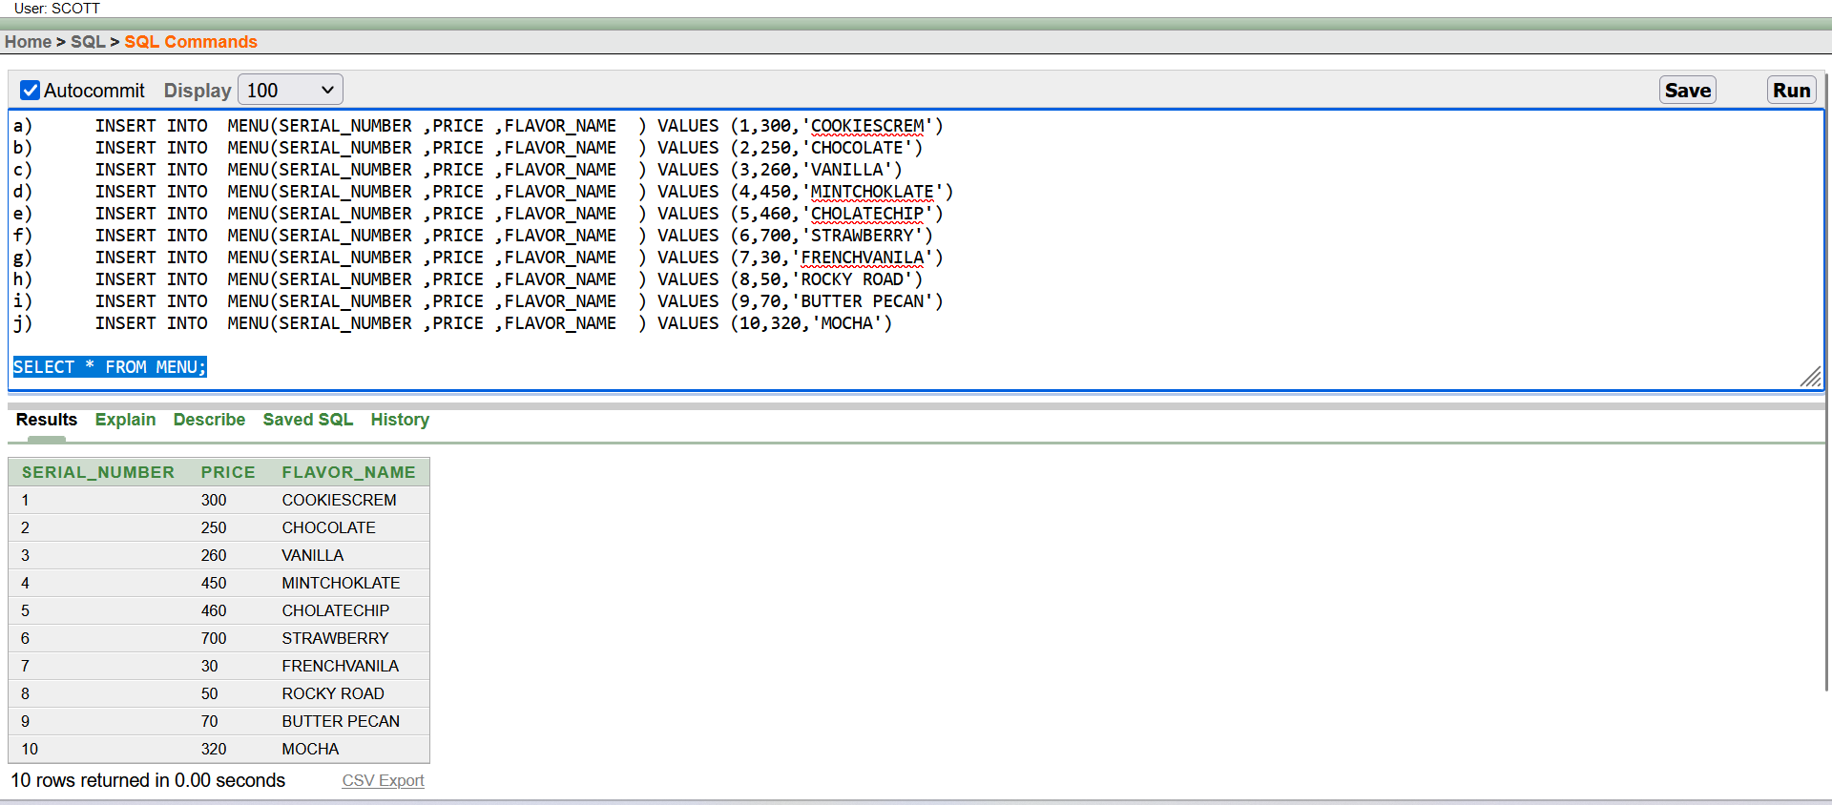

**14. Job_level**

1. INSERT INTO JOB_LEVEL(JOB_ID,JOB_LEVEL_NAME, JOB_SALARY) VALUES (101,'MANAGER',1450)
2. INSERT INTO JOB_LEVEL(JOB_ID,JOB_LEVEL_NAME, JOB_SALARY) VALUES (102,'SALES ASSOCIATE', 1700)
3. INSERT INTO JOB_LEVEL(JOB_ID,JOB_LEVEL_NAME, JOB_SALARY) VALUES (103,'CASHIER', 450)
4. INSERT INTO JOB_LEVEL(JOB_ID,JOB_LEVEL_NAME, JOB_SALARY) VALUES (104,'INVENTORY ASSOCIATE', 2450)
5. INSERT INTO JOB_LEVEL(JOB_ID,JOB_LEVEL_NAME, JOB_SALARY) VALUES (105,'REPRESENTATIVE', 1081)
6. INSERT INTO JOB_LEVEL(JOB_ID,JOB_LEVEL_NAME, JOB_SALARY) VALUES (106,'WAREHOUSE CLERK', 500)
7. INSERT INTO JOB_LEVEL(JOB_ID,JOB_LEVEL_NAME, JOB_SALARY) VALUES (107,'ASSISTANT MANAGER', 6550)
8. INSERT INTO JOB_LEVEL(JOB_ID,JOB_LEVEL_NAME, JOB_SALARY) VALUES (108,'CONTROL SPECIALIST', 630)
9. INSERT INTO JOB_LEVEL(JOB_ID,JOB_LEVEL_NAME, JOB_SALARY) VALUES (109,'FLOOR MANAGER', 1700)
10. INSERT INTO JOB_LEVEL(JOB_ID,JOB_LEVEL_NAME, JOB_SALARY) VALUES (110,'STORE MANAGER', 350)

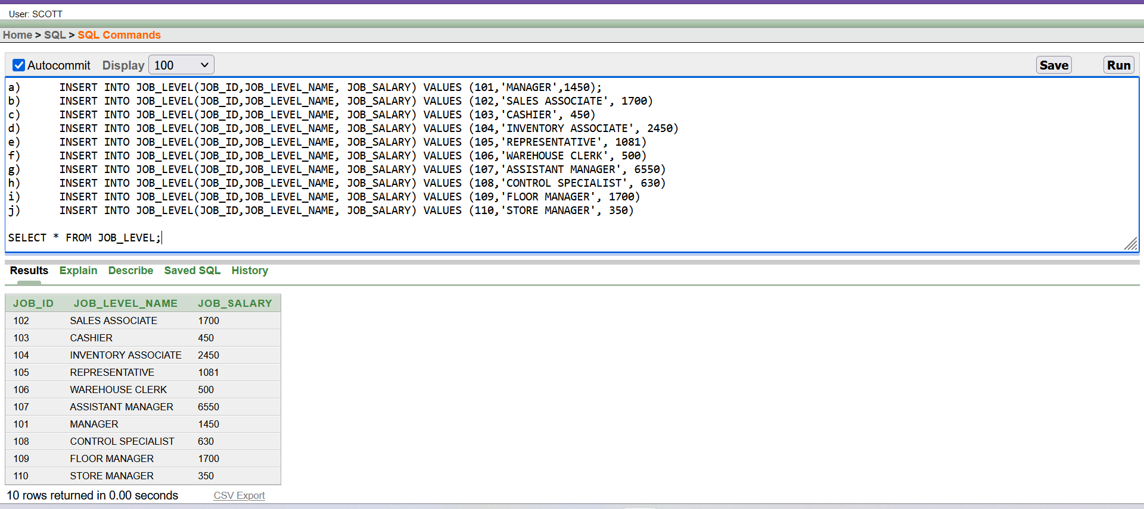

QUERY WRITING :

1. **JONNING** 
   * 1. **EQUIJOIN:** 
        1. Display employee_id, employee_name, salary , trend_licenseand and shop name for employee

Ans :

SELECT E.EMPLOYEE_ID, E.EMPLOYEE_NAME, E.EMPLOYEE_SALARY,S.SHOP_NAME,S.TREND_LICENSE FROM EMPLOYEE E,SHOP S WHERE E.TREND_LICENSE=S.TREND_LICENSE

* + - 1. Display shop_name, member_name and employee_name who serve customer.

Ans :

SELECT S.SHOP_NAME,M.CUSTOMER_NAME,E.EMPLOYEE_NAME FROM SHOP S,MEMBER M,EMPLOYEE E,SERVICE S WHERE E.TREND_LICENSE=S.TREND_LICENSE AND E.EMPLOYEE_ID=S.EMPLOYEE_ID AND S.MEMBER_ID=M.MEMBER_ID

* + 1. **OUTERJOIN**

Display the employee_name, employee_id and job_level_name for all job_level.

Ans:

select e.employee_id, e.employee_name, e.employee_salary,j.job_level_name from employee e,job_level j where e.job_id(+)=j.job_id

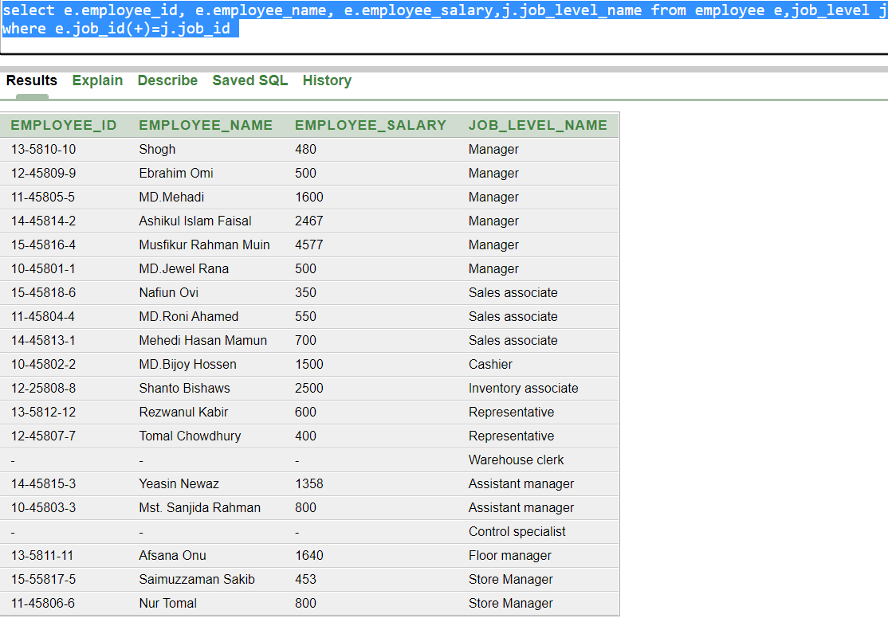

Display employee_name, owner_id for whose employee who get order from owners for all employees.

Answer :

select e.employee_name,r.owner_id from employee e,owner o,orders r where e.employee_id=r.employee_id(+)

* + 1. **Self Join :**

1. Display employee_name and there manager name .

select e.employee_name || ' Manager is '|| m.employee_name from employee e,employee m where e.employee_id=m.manager_id

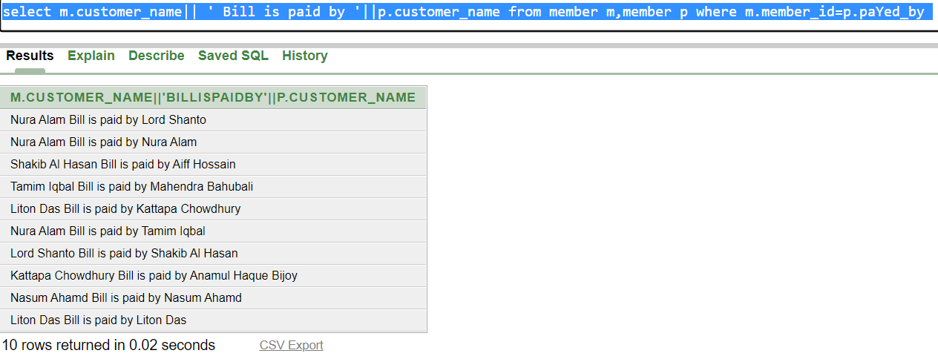

1. Display customer name and Whose name how pay there bill.

Ans :

select m.customer_name|| ' Bill is paid by '||p.customer_name from member m,member p where m.member_id=p.paYed_by

* + 1. **NON EQUIJOIN:**

i) Display Customer_name and shop name for those custom whose date of birth in greater then the shop established and customer age greater then 24 year.

Ans :

select m.customer_name,s.shop_name from member m,shop s where m.dob>s.est_date AND (SYSDATE - dob) > 8760

ii) Display employee_name and there department number who get salary more then average salary from job_salary and less then maximum salary.

Ans :

select e.employee_name,j.job_level_name from employee e,job_level j where e.employee_salary between (select avg(job_salary) from job_level) and (select max(job_salary) from job_level) and e.job_id=j.job_id

2. Sub Query :

i) Display employee name, salary who work in Manager level

Ans :

select employee_name,employee_salary from employee where job_id=(select job_id from job_level where job_level_name='Manager')

ii) Display Member_id, member_name, bill_number who payed 500 .

Ans :

select member_id,customer_name ,bill_number from member where bill_number in(select bill_number from Bill where Total_amount =500)

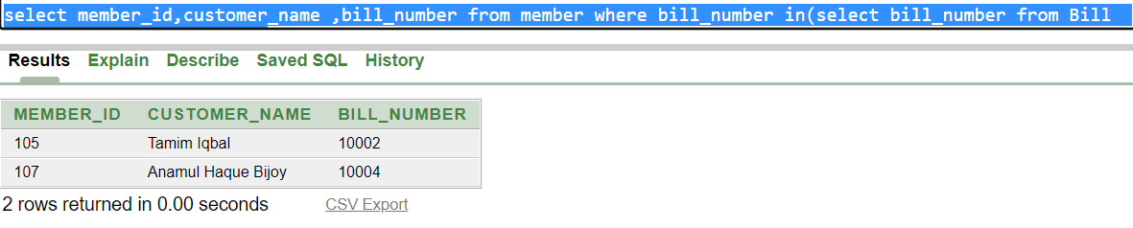

iii) Display Member_id, member_name, bill_number who payed more then 400.

Ans:

select member_id,customer_name ,bill_number from member where bill_number >(select bill_number from Bill where Total_amount =400)

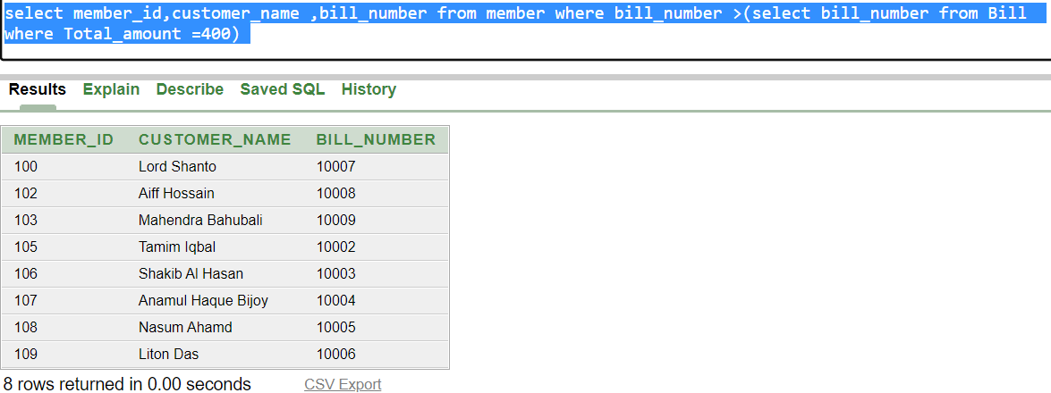

iv) Display employee_name,employee_salary and join_date for shop which is located in Bananni.

Ans :

select employee_name,employee_salary , join_date from employee where trend_license=(select trend_license from shop where location ='Bonanni')

* + 1. Display employee_name, join_date, employee_salary who check Vanilla flavor on stock.

Ans :

select employee_name, join_date, employee_salary from employee where employee_id = (select employee_id from empCheck where flavor_name='Vanilla')

3.SINGLE ROW FUNCTION :

1. Create a query to display the employee_name,empolyee id concat employee name and salary whose id=10-45801-1

Ans :

select employee_name,employee_id, concat(employee_name,employee_salary) as EmpNaSa from employee where employee_id='10-45801-1'

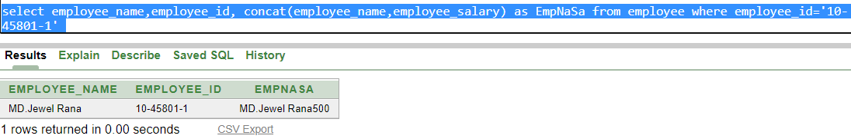

1. Display the employee id, name, and join date for employee Mst. Sanjida Rahman

Ans :

select employee_name,employee_id from employee where Lower(employee_name)='mst. sanjida rahman'

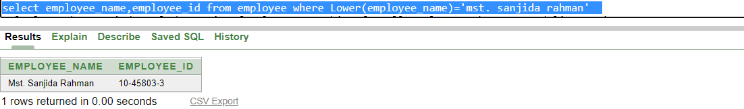

1. Calculate the remainder of the ratio of salary to working for all employees whose treand licence is 81692412

Ans :

select employee_name,employee_salary,working_period, MOD(employee_salary, working_period) from employee where trend_license ='81692412'

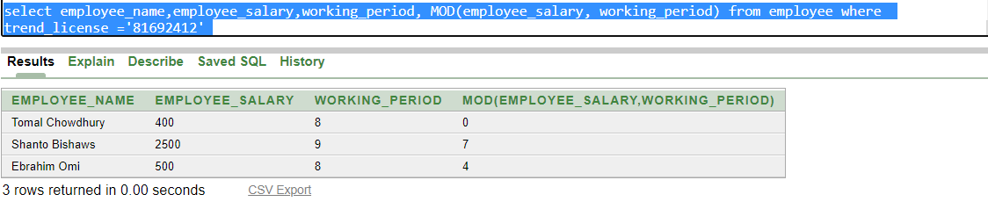

1. display emplyee employee name,salary,working period,Lincense using Character Manipulation Functions

Ans :

select employee_name,employee_salary,working_period,concat (employee_name, trend_license),LENGTH(employee_name),INSTR(employee_name, 'a'),SUBSTR(employee_name,1,2) from employee

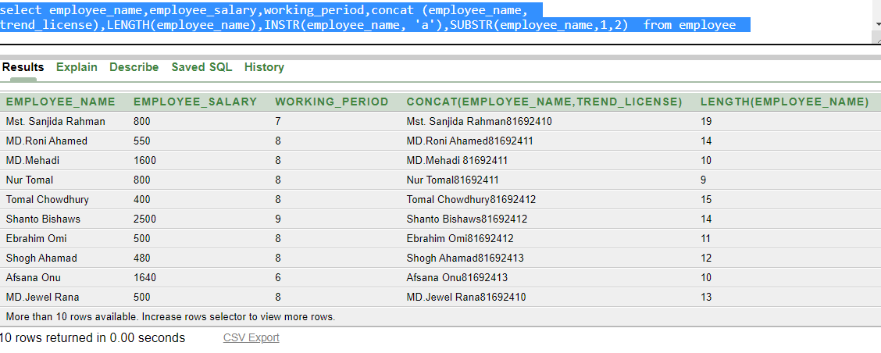

1. Display employee name and convert join date to Caracter.

Ans:

select employee_name, to_char(join_date, 'fmDD Month YYYY') join_date from employee

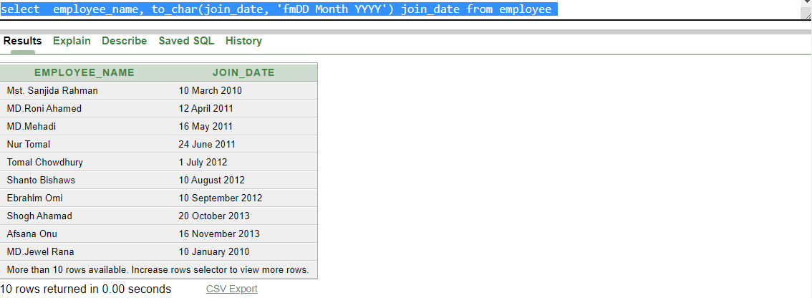

4.GROUP FUNCTION :

1. Display the max, min profit,and average profit from Stock

Ans :

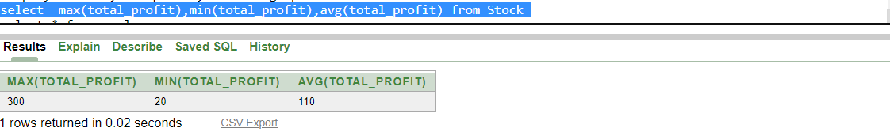

1. Display the employee name, working period, and join date of employee join date between JAN 10, 2010, and NOV 16, 2013. Order the query in ascending order by join date.

Ans :

select employee_name ,working_period,join_date from employee where join_date between '10-Jan-10' and ' 16-Nov-13' order by join_date asc

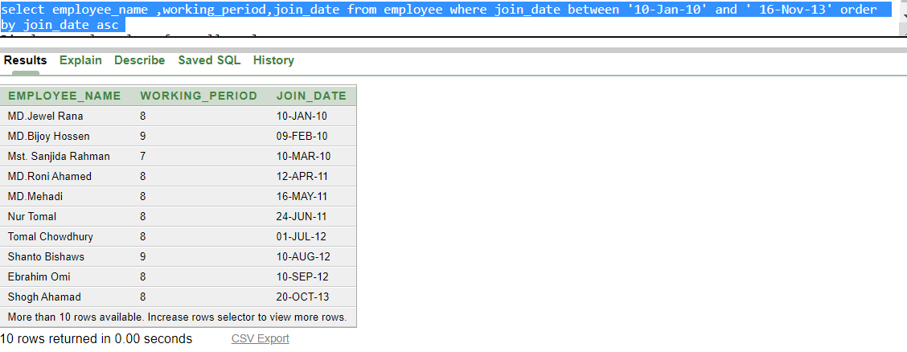

1. Display yearly salary from all employee

Ans :

select sum(12*employee_salary) from employee

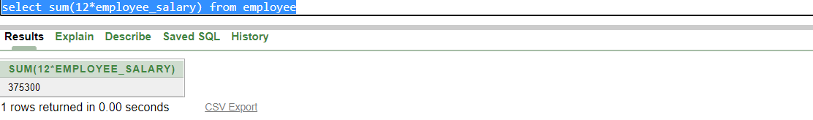

4. dispaly the quary to show the name, salary in descending order who earn lass than maximum salary.

Ans :

select distinct (employee_name),employee_salary from employee where employee_salary < any (select max(employee_salary ) from employee ) order by employee_salary desc

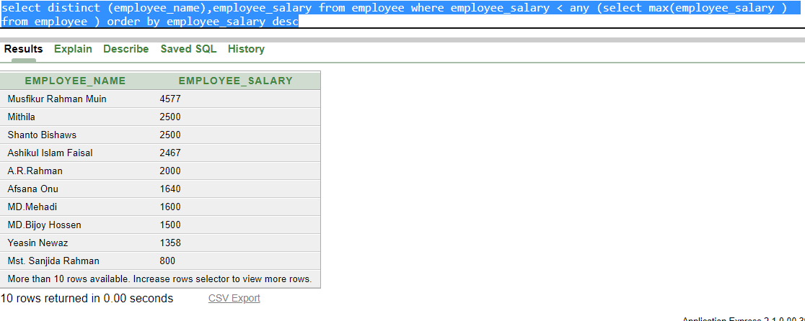

1. Display employee id how many row between employee id 10-45801-1 and 12-45809-9.

Ans :

select count(employee_id) from employee where employee_id between '10-45801-1' and '12-45809-9 '

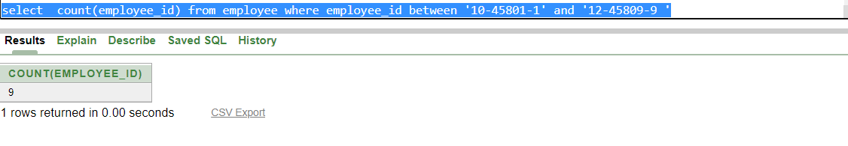

**5. VIEW :**

create or replace view empView as select employee_id,employee_name,employee_salary from employee where employee_salary > (select avg(employee_salary ) from employee)

Display all information of EmpView View.

Inset value in view

1. insert into empView values ('15-45818-7','A.R.Rahman',2000)
2. insert into empView values ('15-45819-8','Tahsan Khan',5000)
3. insert into empView values ('15-45820-9','Mithila ',2500)

**6. Sequence :**

Create Sequence member_sequence

INCREMENT BY 1

START WITH 110

MAXVALUE 1000

NOCACHE

NOCYCLE

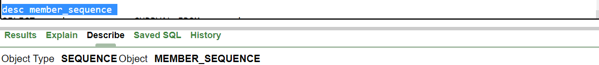

Data Insert by using Sequence

7. GENERAL QUERY :

1. Display all information about employee whose name have latest one a and job_level_name is not Manager.

Ans :

select * from employee where employee_name like '%m%' and job_id <> (select job_id from job_level where job_level_name='Manager')

2. Display customer_name,member_id and total bill who paid more then average bill and less then maximum bill.

Ans :

select distinct(m.member_id), m.customer_name,b.total_Amount from member m,bill b where m.bill_number in(select bill_number from bill where total_Amount > (select avg(total_Amount ) from Bill ) and total_Amount <(select max(total_Amount ) from Bill) ) and m.bill_number=b.bill_number.

3. Display employee name ,employee id , joining date who work for shop at least 5 year.

Ans : select employee_id,employee_name,join_date from employee where (sysdate-join_date)/365>10

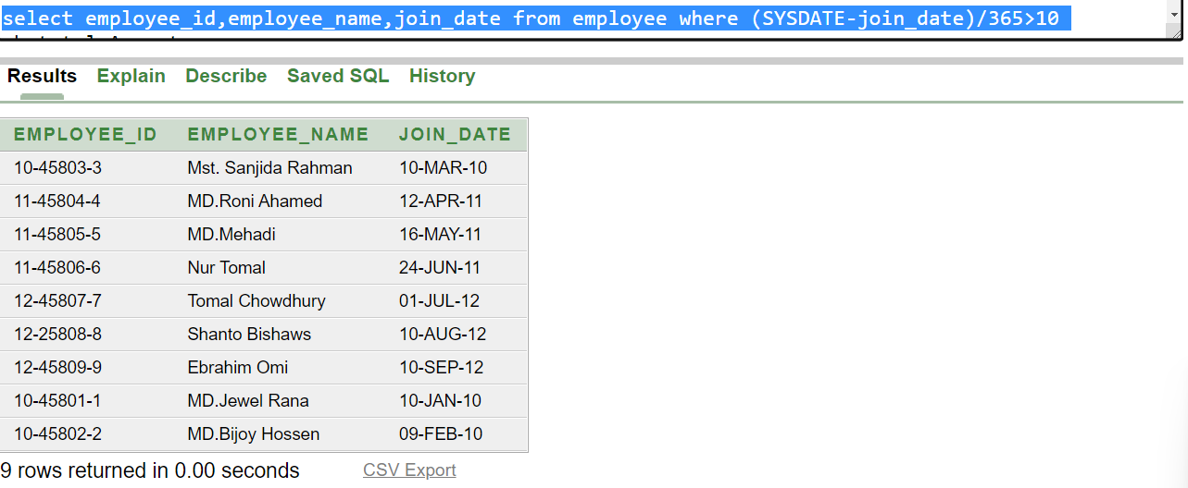

1. Display member_id, customer_name, dob who born after the member whose name start with L.

Ans :

select member_id,customer_name,dob from member where dob > any (select dob from member where customer_name like 'L%')

1. Display shop_name, owner_name, owner_id of a shop.

Ans:

select s.shop_name,o.owner_id,o.owner_name from shop s,owner o where o.trend_License=s.trend_License

